Quality Review and Exchange System for Tribes (QREST)

Users Guide



Updated May 20, 2024



[www.open-environment.org](http://www.open-environment.org)

**Table of Contents**

1 Introduction 4

1.1 QREST Overview 4

2 Getting Started 6

2.1 Registering an Account 6

2.1.1 Email Verification 8

2.1.2 Logging In To QREST 9

2.1.3 Retrieving Lost Password 9

2.2 Secure Dashboard 10

3 Tribe Management 11

3.1 Editing Your Tribal Organization 11

4 Site Management 14

4.1 Site Listing 14

4.2 Site Data Retrieval from AQS 16

4.3 Monitor Management 17

4.4 Monitor Retrieval from AQS 19

4.5 Polling Configuration 20

5 Air Data Management 26

5.1 Air Data Retrieval and Processing Workflow 26

5.1.1 QREST Polling Task 26

5.1.2 Hourly Data Calculation (automatic) 27

5.1.3 QREST Alert Notification Task 27

5.2 Raw Data 28

5.3 Quality Assurance: Data Review 28

5.3.1 Data Review Workflow 28

5.3.2 Data Review Documentation 32

5.3.3 Advanced Review Options 33

5.4 Manual Raw Data Import 34

5.4.1 Introduction 34

5.4.2 Setting Up an Import Template 35

5.4.3 Importing Data 37

5.4.4 Import History 38

5.5 Quality Control 39

5.5.1 QC Types 39

5.5.2 QC Data Entry 41

5.5.3 AQS QC Data Submission 43

5.6 AQS Raw Data Submission 45

5.6.1 Initial QREST Configuration Required Before Making AQS Submissions Through QREST 45

5.6.2 Making An AQS Submission 47

5.6.3 Troubleshooting AQS Submission Problems 51

6 Public Website 52

6.1 Public Map 52

6.2 Reports 52

6.2.1 Daily Hourly Data 52

6.2.2 Monthly Hourly Data 53

6.2.3 Annual Hourly Data 54

# Introduction

This document is one of 3 documents that, taken together, fully document the QREST software. The 3 documents are:

1. **QREST User’s Guide**
2. QREST Administration Guide
3. QREST Technical Architecture and Cloud Hosting Plan

|  |  |
| --- | --- |
| **🗹 This Guide Is For** | **🗷 This Guide is NOT For** |
| **Tribal Administrators**   * Responsible for managing Sites & QREST users for their tribe   **Tribal Data Certifiers or Users**   * Responsible for setting up polling configuration for their monitors * Responsible for certifying or making AQS submissions | **Global QREST Administrator(s)**   * Responsible for overall operation and maintenance of QREST * Responsible for software installation   *(instead refer to the QREST Administrator’s Guide)* |

## QREST Overview

QREST is a set of software tools that includes the following features:

* **Data Logger Integration:** Integrate with tribal data loggers to automatically retrieve air monitoring data
* **Automated Data Averaging:** As n-minute data are streamed into QREST, hourly summaries are immediately calculated and stored, using calculation logic defined for a tribe’s specific monitoring conditions. QREST is capable of calculating averages, mins, maxes, angular averages, totals, standard deviations, and angular (Yamartino) standard deviations.
* **Automated Data Validation & Alerting:** as data is streamed into QREST, validation checks are automatically performed. Designated tribal operators are notified of exceptions, via email and/or text message. This includes notification of missing data, indicating data logger communication is interrupted.
* **Manual Data Upload:** Support for manual upload of data logger files in lieu of automated data integration
* **Multi-Phase Data Review:** More quickly conduct the 1st phase of data review, by using QREST’s functions to automatically flag data using the 3 factors of the initial data review. Fulfill the independent quality assurance function required for regulatory and legally-defensible data, by providing a structure for the two levels of separation required between data gatherer and final data validation as required by CFR and all quality system requirements (ISO).
* **Quality Control:** Manage single-point QC, Annual Performance Evaluations, Flow Rate Verifications, Semi-Annual Flow Rate Audits (for particulate matter), and Zero/Span checks
* **AQS Integration:** Push raw data (RD) and quality control (QA) data to EPA’s Air Quality Subsystem (AQS) via EPA’s Exchange Network. In addition, AQS reference data and other relevant codes and limits are pushed to QREST users when EPA makes changes
* **AirNow Integration:** tribes can opt to stream data from QREST to EPA’s AirNow program
* **Data Sharing with Public:** map-based website allowing tribes to share air data with the public, with options to download data reports
* **API Access:**3rd party applications can integrate with QREST via API web services

The following diagram outlines the various methods you can get your air quality data into QREST:



# Getting Started

## Contact ITEP to Get Agency Added to QREST

If your tribal agency is not yet in QREST, contact ITEP to get your agency added.

## Registering an Account

The QREST home page provides a link for users to register an account, as shown here:

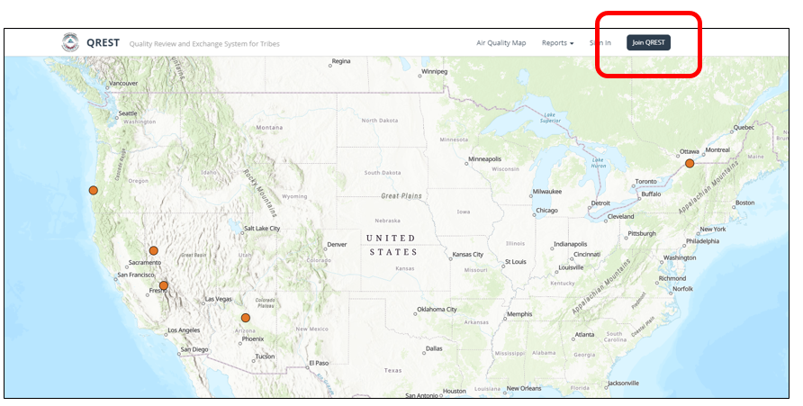

And can then click on the **“Join QREST”** link at the top to navigate to this page:

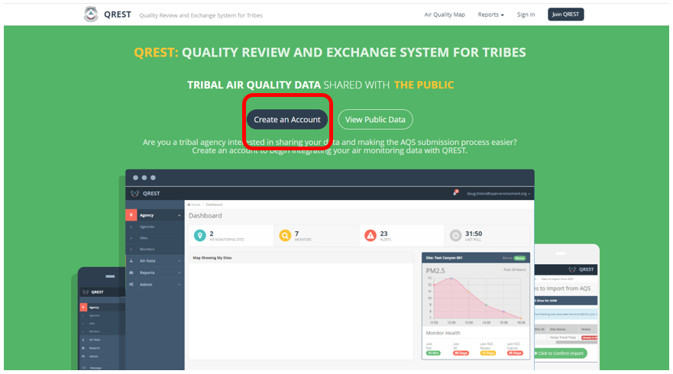

Then click on the “**Create an Account**” button, which displays the Registration page:

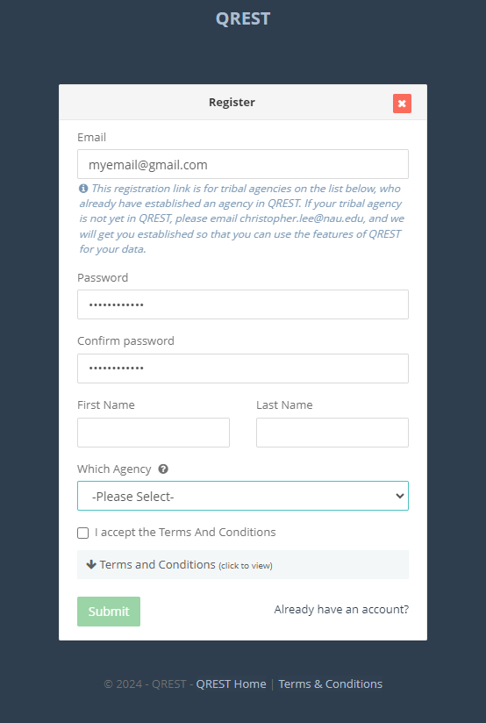

**Registration Details:**

* The user can self-register a user account by supplying the following:
  + Email address
  + Password

|  |
| --- |
| Password Security Requirements |
| * Must be at least 8 characters in length |
| * Must consist of at least 4 unique characters (e.g. AAABBBCC is not allowed) |
| * Email must be unique (no 2 QREST accounts with same email address) |
| * Will be checked against a list of the 100,000 most common passwords and rejected if the user is using one of these common passwords. This security measure is added to protect against common dictionary hacking attacks |

* + First and Last Name
  + Tribal Agency: The user can optionally supply a tribal organization to be associated with
    - The only agencies appearing in the drop-down are those who have
      * (1) been setup in QREST, and
      * (2) specified that registration is enabled for that agency
* The user must accept the Terms and Conditions in order to Register

***Note:*** *some tribes in QREST may restrict registration to only allow individuals matching certain email patterns to register an account (e.g. Cherokee Nation may only allow individuals with* [*\*\*\*\*@cherokee.org*](mailto:****@cherokee.org) *emails to register QREST accounts, as a anti-spam measure.*

When the user registers, they will be presented with the following screen informing them that their account has been registered and email verification is required:

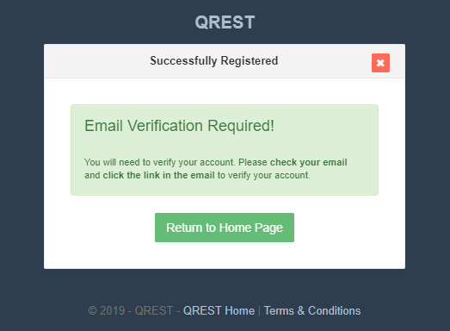

### Email Verification

An email will be sent to the user with a link within that they must click to verify their email address. If the user attempts to login to QREST prior to verifying their email, they will be unable to and shown the following screen:

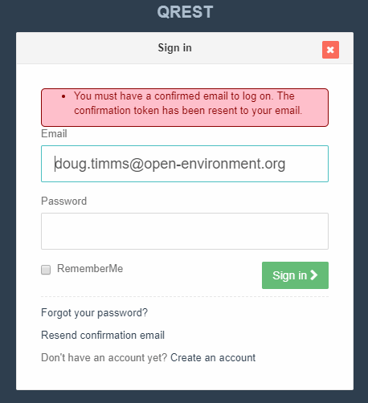

When the user clicks the link in their verification email, they will be shown the following screen:

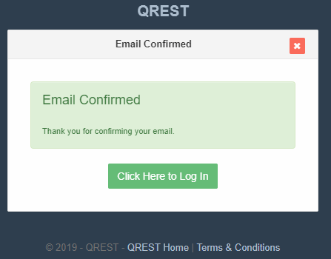

### Logging In To QREST

The user will then be able to log to QREST at the login page:

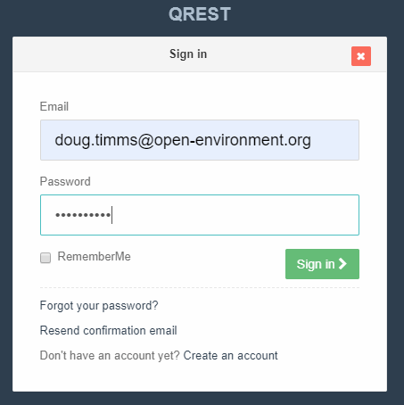

### Retrieving Lost Password

If a user forgets their password, they can navigate to the Sign In page and click the **Forgot Your Password** link, which will allow them to enter in the email address that they originally registered their account with, as shown here:

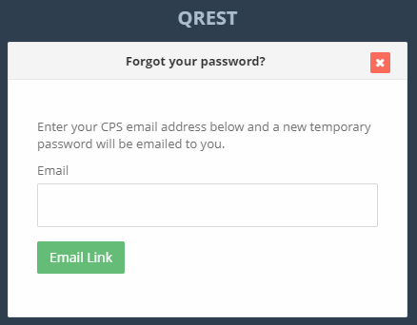

Once entered, a link will be emailed to them that they must click to reset their password. This link will expire if not acted upon within 24 hours.

## Secure Dashboard

When a user logs in to the secure portal portion of QREST, they are shown the QREST Dashboard:

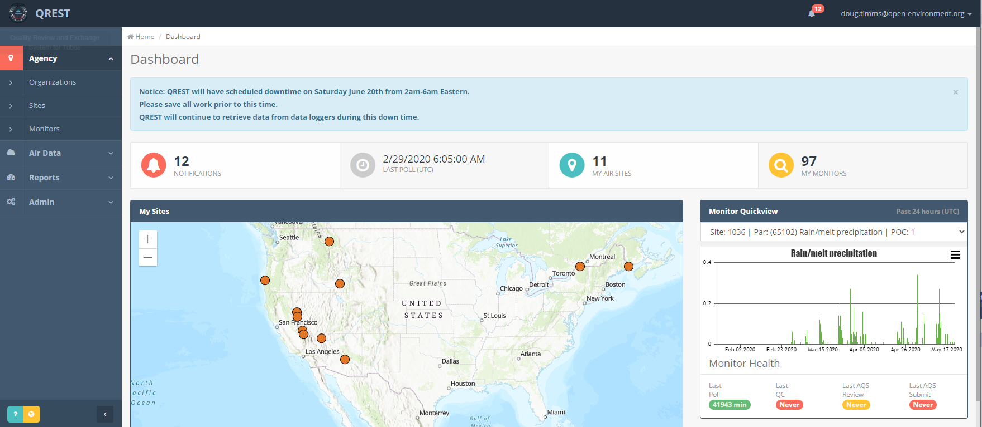

Content of the dashboard is broken into these components:

**Left Menu:** this is where people can navigate to most QREST screens.

**Main Dashboard Panel:** this is where information that a user wants quick access to is viewable.

**Custom Message:** QREST Administrators can convey a message to users upon logging in, such as notifying about upcoming site downtime or other important warnings.

**Alerts:** this will display a count of how many alerts are active for the user, if the user has “In-App Alerts” enabled in their User Profile. When the user clicks on the alert icon, it will show the active alerts they have and let them navigate to an alerts page to view them more fully.

**Top Menu:** top menu provides access to (1) User Profile (2) Online Help and (3) Logging out.

**Link to Public Site, Page-Specific Online Help, and Training:** when the user is logged in, they can click the yellow button to navigate from the secure dashboard to the public site. In addition the user can click on the blue button to display page-specific online help related to whichever page the user is currently viewing in QREST. In the test QREST site, the user can also click here for online training courses.

# Tribe Management

The ITEP QREST Administrator is responsible for creating the organization (aka Tribal Agency) record. (After the QREST admin creates the organization record and assigns a tribal administrator, then the tribe can manage data from then on.)

The **Agency 🡪 Organizations** screen lists all tribal agencies that the logged-in user has access to, as shown here:

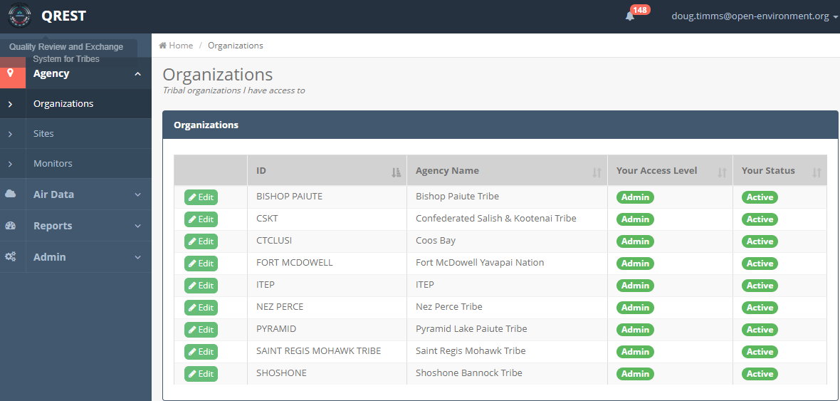

For each organization the user has access to, the access level and status is shown. If the user has Administrative access for the agency, they can click the  button to edit an organization.

## Editing Your Tribal Organization

When editing your organization, the tribal administrator can edit a variety of information, as shown here:

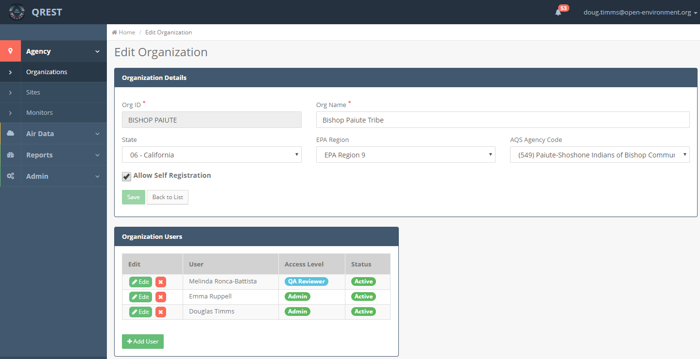

* Org ID and Name (mandatory)
* State
* EPA Region
* **Allow Self Registration:** indicates if the agency appears on the dropdown when new users register a new QREST account.
* **AQS Agency Code:** it is important that this be set properly in order to make AQS submission and to import sites or monitors for this agency from EPA-AQS into QREST.
* **Organization Users:** these are the listing of QREST users who have access to the organization’s data.
  + User’s Access Level: A user can a particular access role for the organization. Please refer to the section on **Account Types** for a full description of each access level
  + User Access Status: can be
    - Active
    - Pending
    - Rejected (which also acts the same as deleting the user from the organization)

The Administrator can click on the  button to add a new user’s access to the organization.

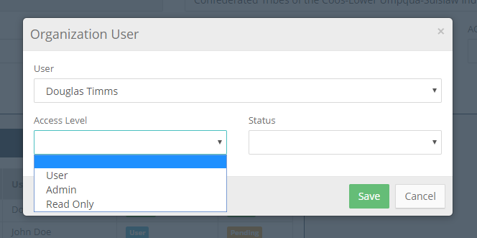

QREST supports different account types, each with different access levels. The following table summarizes these:

|  |  |
| --- | --- |
| Account Access Level | What Can You Access |
| **Read Only** | Can only view data for the organization but cannot edit any data |
| **Operator** | Can edit site and monitor data. Can edit hourly data and can perform Level 1 validation of data |
| Tribal Access Level: **QA Reviewer** | Can perform everything an operator can plus can perform Level 2 validation of data |
| Tribal Admin | Can perform everything a QA Reviewer can plus allow other users to join the organization (or change their access level) |

Here’s a more detailed breakdown of the functions that can be performed by the different roles:



# Site Management

## Site Listing

Each tribe can manage the air monitoring sites for the tribal agencies they have access to. First navigate to the **Site List** screen to see a listing of their sites, as shown here:

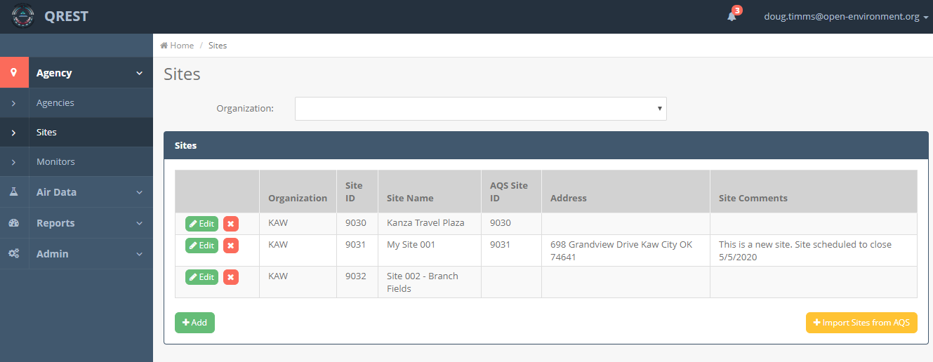

The user can click on the  button to edit a site that has already been created, or click on the  button to create a new site. Both actions will load the **Site Edit** page, as shown here:

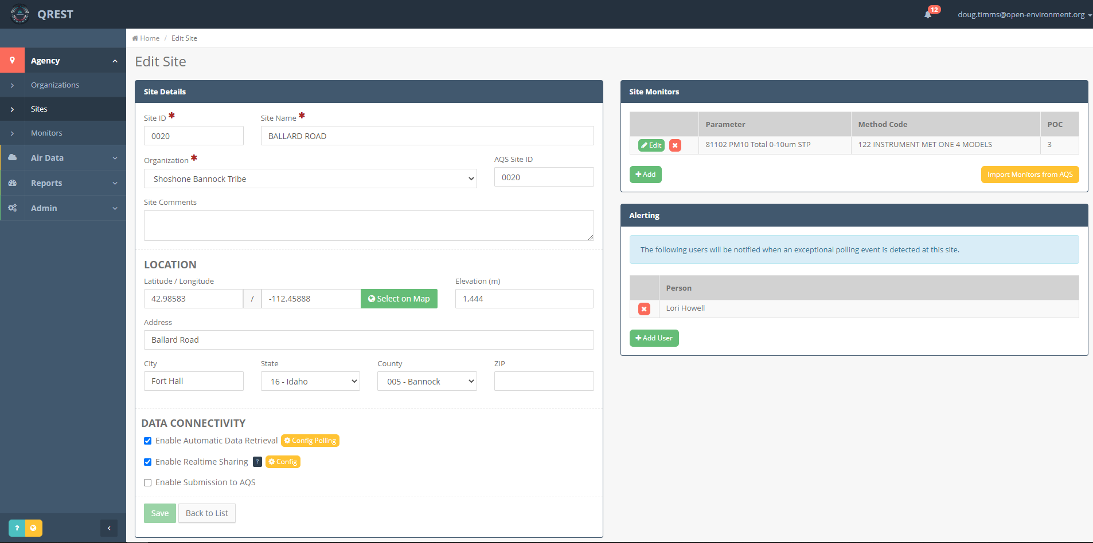

The following information can be edited for a site:

* **Site Details**
  + Required fields *(marked with red asterisk):*
    - Site ID, Site Name, and Organization
  + Non-Mandatory Fields:
    - AQS Site ID and Comments.
* **Site Location:** Site Address, elevation, and latitude/longitude. The system will allow the user to select the latitude/longitude by clicking on a map, as shown here:

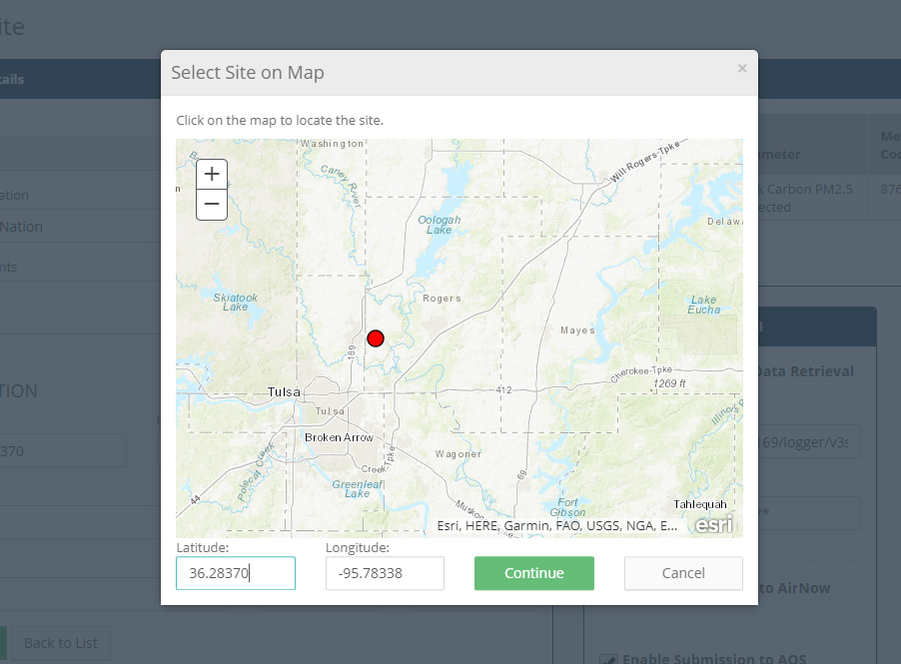

*(The system will prompt with an error message if the user attempts to save a latitude/longitude that falls outside of general US proximity.)*

* **Data Connectivity:** the user can turn on or off different data connectivity settings for this site.
  + **Automatic Data Retrieval:** When turned on, QREST’s automated service will attempt to poll the site according to the polling configuration currently defined for the site (see Polling Config section for more information about site polling configuration).
  + **Realtime Sharing:** If this is enabled, the site will appear on the public map. In addition, if AirNow credentials are correctly supplied, QREST will share hourly monitoring data with EPA’s AirNow program.
  + **Submission to AQS** *(not currently used – AQS submissions can be made regardless of this setting)*
* **Site Level Alerting:** the user can define which QREST users should receive a notification when monitors at this site fail the 4 automatic checks (valid ranges, record-to-record changes, stuck values, and non-numeric error codes). The type of notification that a user receives is set at the User’s Profile screen, where they can select:
  + In-App Notification
  + Email Notification
  + Text Message (SMS) Notification
* **Site Monitors:** defines the parameters that are monitored at the site (see next section)

## Site Data Retrieval from AQS

The user can import site records from AQS. This will alleviate the need to have to re-enter these sites into QREST. At the Site List page, click the  button to import sites from EPA. QREST will retrieve AQS sites based on the AQS Site ID entered on the Site Edit page – make sure that AQS Site ID is accurate before attempting import.

QREST will retrieve sites from EPA using the following link:

* <https://aqs.epa.gov/aqsweb/codes/qa/SitesV4.txt>

QREST will then display these sites for the agency and give the user the opportunity to confirm if they want to import the sites.

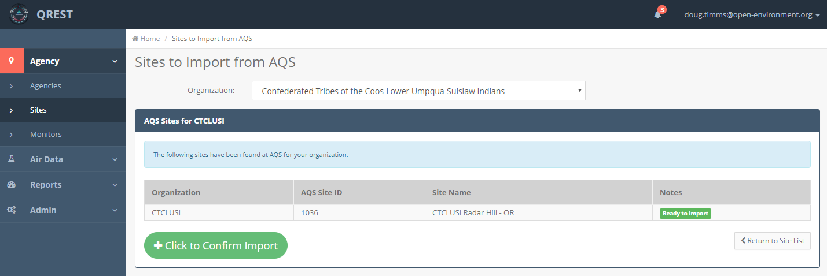

The user can then click the  button to confirm the import.

## Monitor Management

For each air collection site, a user can define what parameters are being monitored at that site. This includes identifying the parameter (i.e pollutant) being monitored, the unit of measure of collection, the method of data collection, etc.

To add a new monitor for a site, navigate to the Agency 🡪 Sites 🡪 Site Edit page and click the **Add** button in the Site Monitors section, as shown here:

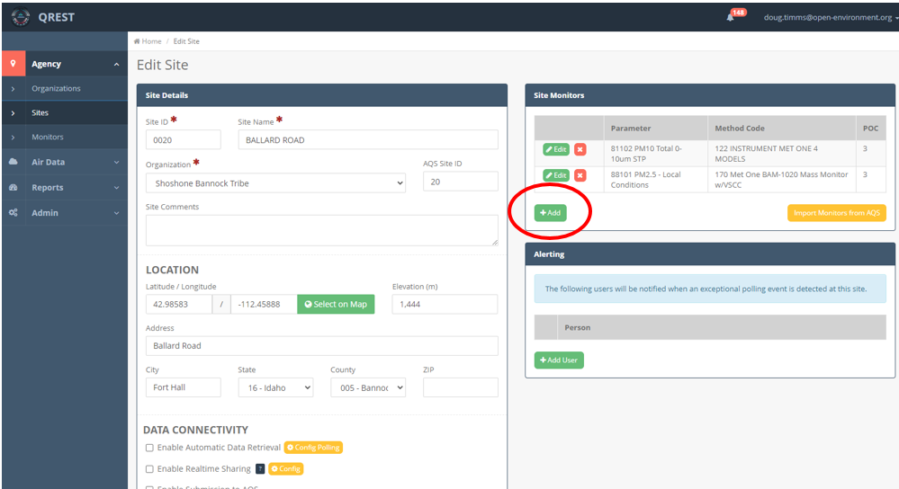

When adding a monitor the user can search parameters / methods by AQS parameter code, parameter name, or method code by typing in the search box:

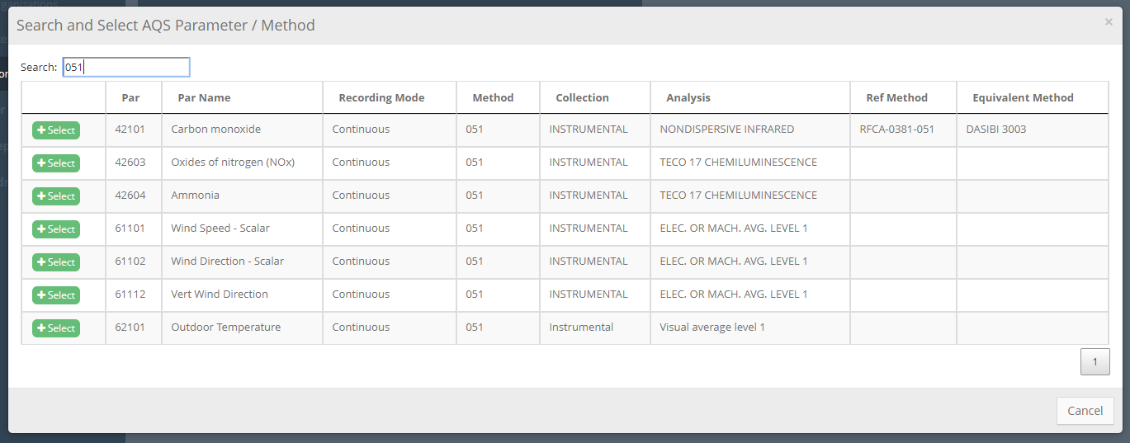

The user can then enter in the POC, AQS Reporting Duration, Collection Frequency, Data Collection Units and alerts.

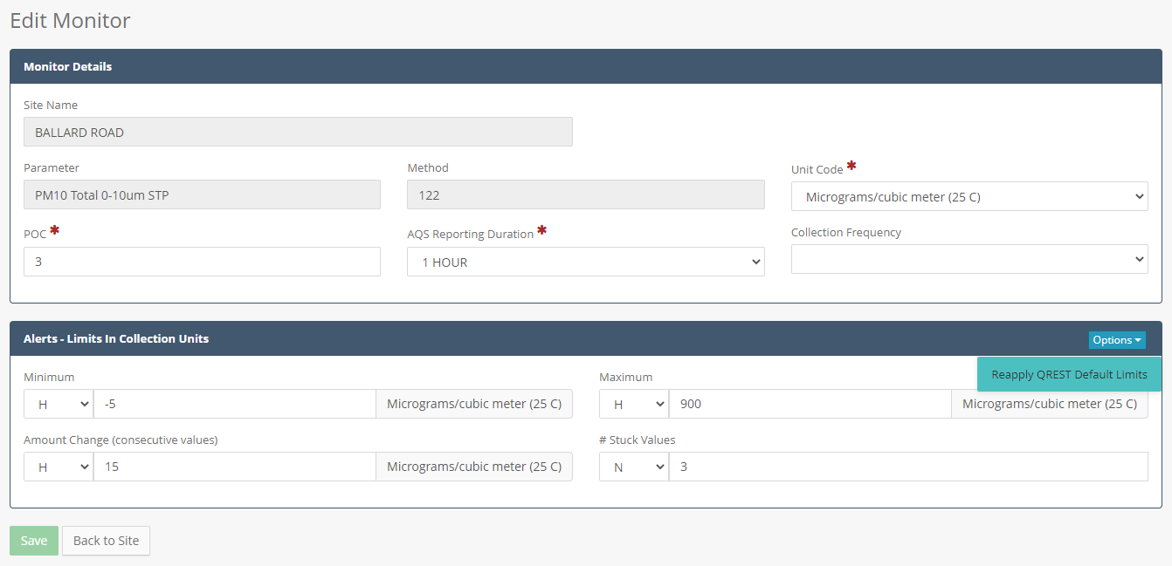

**Alerts:**

Alerts can be applied to a monitor. These alerts will be automatically checked by QREST when data is retrieved from data monitors. If an alert condition is met, then users who are included in the alert list for the site will receive an alert. The alert will be received either as an in-app notification, email, and or text message, depending on the user’s own preferences. The alert can be defined either for n-minute data or on calculated hourly averages.

The alerts are:

* **Minimum value:** any values collected below this value will trigger an alert
* **Maximum value:** any values collected above this value will trigger an alert
* **Amount Change:** any consecutive (i.e. back-to-back) values with a difference in excess of this amount will trigger an alert. For example if two consecutive readings are 5ppm and 16ppm and the Amount Change limit is set to 8ppm, this alert will trigger because the difference (11ppm) exceeds the specified alert limit.
* **# Stuck Values:** any # of consecutive readings stuck with the same value will trigger an alert

**Default Alerts:** When a new monitor is added in QREST, QREST will automatically apply default alerts for that parameter/method combination, if any exists. The user can then replace them on the screen above. The default min/max alerts come from AQS reference data, and the “amount changed” alert is determined to be 3 times the value of the minimum alert.

**Reapply Default Alerts:** If the user changes the default QREST alerts for the monitor and wishes to reset them back to their original defaults, they can click on the **Options** button and click on the **Reapply Default Limits** button.

## Monitor Retrieval from AQS

Similar to sites, monitors can be imported from AQS. This uses a different API from AQS, located at <https://aqs.epa.gov/aqsweb/documents/data_api.html>. In particular, a call to the following API will retrieve monitors for a particular site:

https://aqs.epa.gov/data/api/monitors/bySite?email=**PAR1**&key=**PAR2**&bdate=20000101&edate=20251231&state=**PAR3**&county=**PAR4**&site=**PAR5**

Where:

* Par1 = AQS API username
* Par2 = AQS API password
* Par3 = The State defined for the Site on the Site Edit page
* Par4 = The County defined for the Site on the Site Edit page
* Par5 = The AQS Site ID defined for the Site on the Site Edit page

This will return data in JSON format that will be parsed and inserted to the Monitors table. The monitors will be displayed to the user as shown below:

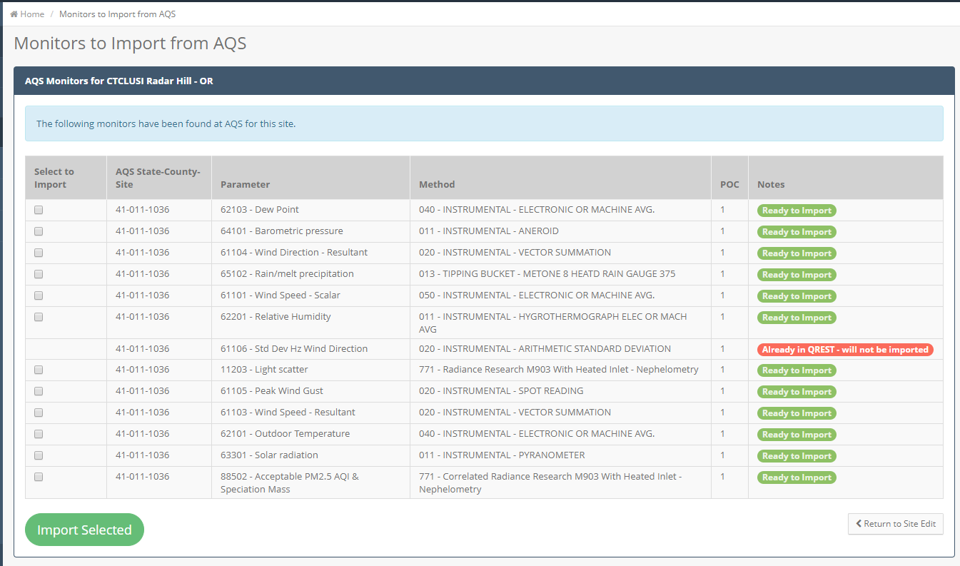

The user can then select the monitors they wish to import. QREST will check if the monitor is already in QREST and not allow the user to import.

## Polling Configuration

QREST currently supports the automated retrieval of data from the following data loggers:

* **Zeno 3200 Data Logger**, with CCSAIL data publishing enabled
* **Sutron XLite 9210 Data Logger**, with CCSAIL data publishing enabled
* **Weather Underground Personal Weather Station (PWS)** sites that are joined to the PWS network

In order to retrieve data from loggers you need to first define a polling configuration. This is done by navigating to **Agency 🡪 Sites 🡪 Site Edit** and then clicking on the **Config Polling** button, as shown here:

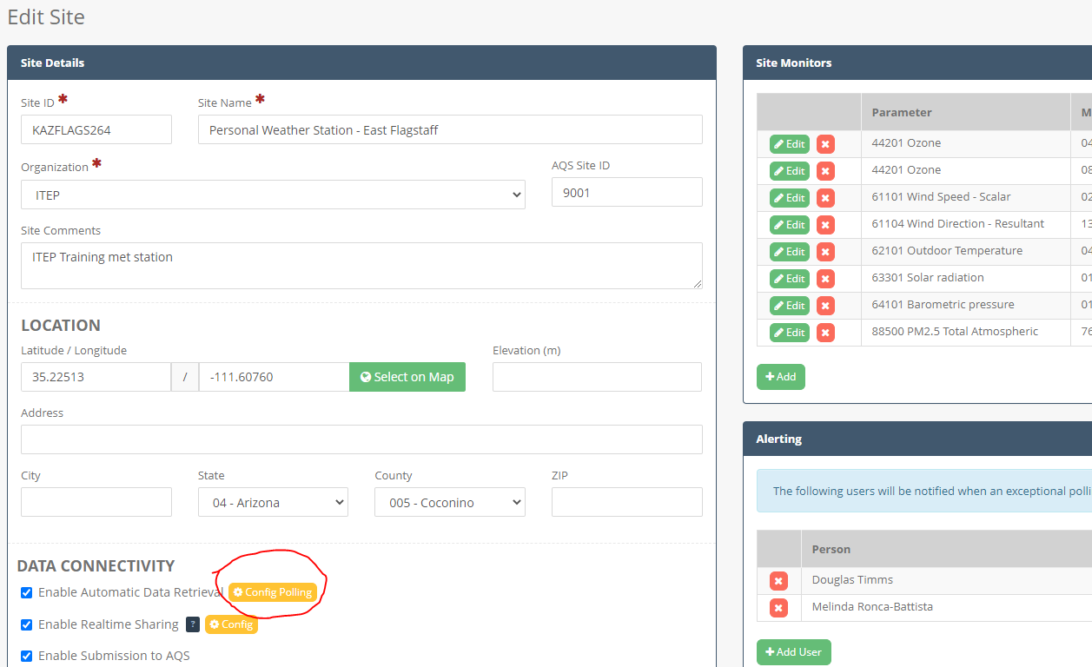

This will load the Site Poll Config page as shown here:

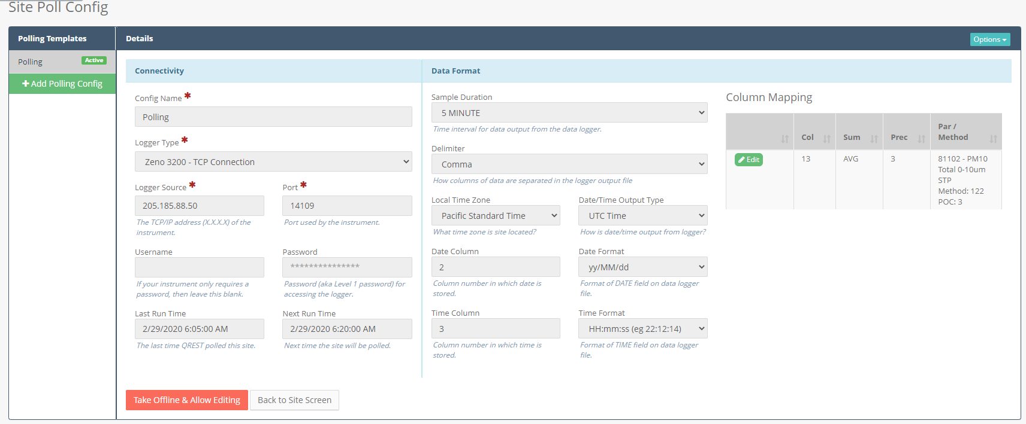

Fields to set a logger configuration include:

* **Config Name:** give your polling configuration a meaningful name. Although in the vast majority of situations, people only define 1 polling configuration per site, there are scenarios where a site may have different seasonal polling configurations and the **Config Name** will help you keep track of these different configurations.
* **Logger Type:** 
  + Zeno (for a Zeno 3200 data logger with an available IP-based connectivity)
  + Sutron (for a Sutron XLite data logger with an available IP-based connectivity)
  + Weather.com Personal Weather Station
* **Logger Source:**
  + Zeno/Sutron: If configuring a Zeno or Sutron logger, enter the public IP address (e.g. XXX.XXX.XX.XX) where the logger is located
  + PWS: If configuring a weather.com personal weather station, provide the name of the weather station, as published at api.weather.com. The Logger Source should be the station ID that would replace the XXXXXX in the following link: [https://api.weather.com/v2/pws/observations/current?stationId=**XXXXXX**&format=json&units=e&apiKey=YYYYYYY](https://api.weather.com/v2/pws/observations/current?stationId=XXXXXX&format=json&units=e&apiKey=YYYYYYY)
* **Port:** destination port for data retrieval (required when connecting to Zeno / Sutron loggers)
* **Username:** if logger requires a username to retrieve data. For Zeno loggers, this is not used
* **Password:** if logger requires a password to retrieve data.
  + For Zeno loggers, this is the Level 1 password
  + For Weather.com this is the API Key for the Weather Company web service
* **Sample Duration:** time interval that the logger is outputting data. If set to “5 MINUTE”, QREST will retrieve the 5-minute data and also calculate hourly data from the 5-minute raw data. Otherwise QREST will just retrieve the hourly data from the logger and store it.
* **Delimiter:** How columns of data are separated in the logger output file
* **Local Time Zone:** the time zone in which the site is located
* **Date/Time Output Type:** identifies how data is being output on the data logger, either in local standard time or UTC time
* **Date Column:** Column number in which date is stored.
* **Date Format:** Format of DATE field on data logger file.
* **Time Column:** Column number in which time is stored.
* **Time Format:** Format of TIME field on data logger file.

**Column Mapping**

* **Column Mapping:** the column mapping section allows the user to define the parameters that are monitored at the site. For each parameter being logged by the logger, define:
  + **Parameter/Method:** parameter/method stored in the specified column
  + **Column #:** Column number in which the parameter appears in the data logger file. For example, if the data logger is producing the following data file:

1128,20/06/19,02:45:00,0,1,K,4.20,**2,K,221.50**,3,K,21.40,4,K,4.40,5,K,8.70,35,K,16.2488

1128,20/06/19,02:50:00,0,1,K,5.60,**2,K,225.80**,3,K,15.70,4,K,5.80,5,K,9.00,35,K,17.9745

1128,20/06/19,02:55:00,0,1,K,5.50,**2,K,218.70**,3,K,17.30,4,K,5.70,5,K,9.50,35,K,16.0348

1128,20/06/19,03:00:00,0,1,K,5.50,**2,K,221.00**,3,K,16.50,4,K,5.70,5,K,8.90,35,K,11.7177

1128,20/06/19,03:05:00,0,1,K,5.40,**2,K,226.00**,3,K,17.60,4,K,5.50,5,K,8.90,35,K,9.4351

**1 2 3 4 5 6 7 8 9 10**

And Wind Direction is configured in your Zeno logger on Channel 2 (in red above), the column # value would be **10** because the Wind Direction values above (221.50, 225.80, 218.70, 221.00, 226.00) appear in the 10th column in the file above.

*(Note: if you are retrieving data from a weather.com weather station, the column numbers are ignored)*

* + **Summary Type:** What calculation should be performed in summarizing the n-minute data from the logger into hourly data. If the data being pulled from the logger is hourly (or this is a weather.com weather station), then this is ignored.
  + **Rounding Decimals:** Number of decimal places to be used when calculating hourly data from the n-minute data coming from the logger
  + **Adjustment Factor:** if data values need to be adjusted by a factor before storing in QREST. For example, if the data logger outputs Ozone in Volts but you want QREST to store Ozone in parts per billion, you would enter an adjustment factor of 500 (V -> ppb  x 500)

**Locking, Editing, and Change Log:**

Once a polling configuration is saved and set to active, it is locked. To make subsequent changes, you will need to click the **Take Offline & Allow Editing** button. This will set the Polling Configuration into edit mode. Then you can make changes and also write notes to describe the changes you are making. In addition, QREST will record each field change you make and log it. So for example if you change the time column from column 2 to column 4, this type of change will be logged.

You can view a complete history of all changes made to the Polling Configuration under the **Options 🡪 View Change Log** menu. This will display a log that looks like this:

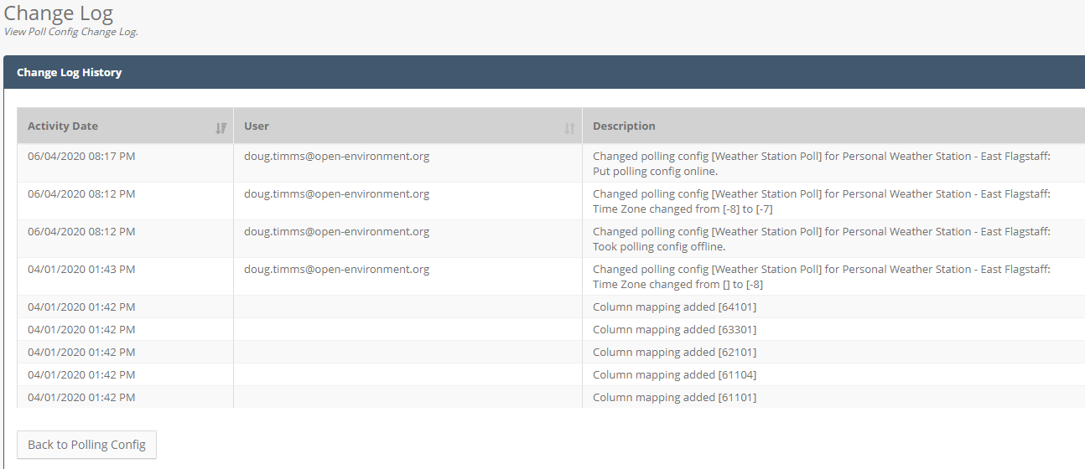

**Deleting a Polling Configuration:**

You can delete a Polling Configuration by first setting it to Inactive (click the **Take Offline & Allow Editing** button). Then access the Delete option under the **Options** menu.

**Pinging Logger:**

The user can use QREST to test the connectivity with a data logger. This is useful in verifying if the connection details (IP address, port, and if needed username and password) are properly configured in QREST. Ping is available under **Options** on the **Site Poll Config** page:

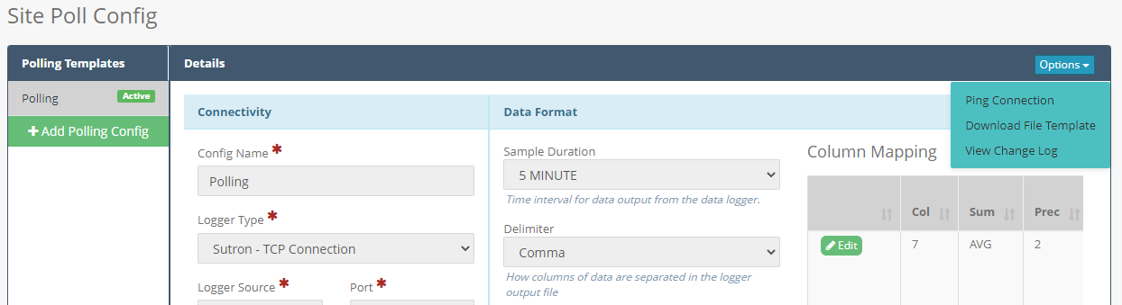

There are two ping options:

* **Ping Only (only available for Zeno loggers):** Will attempt to establish a connection with the data logger and if successful disconnect from the logger. If the test is successful it will look like the following:

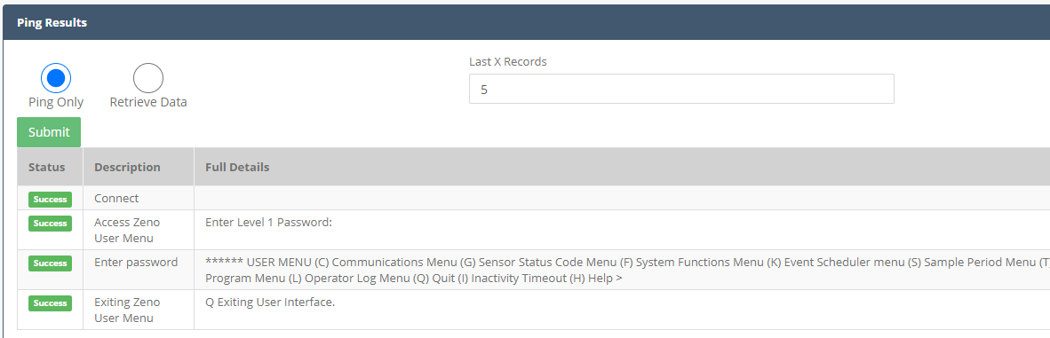

* **Retrieve Data (only available for Zeno and Sutron loggers):** Will attempt to establish connection with the logger and download a small set of data. You can specify how many data records will be retrieved in the **Last X Records** textbox. Results of the ping/retrieval will be displayed to the user as shown here:

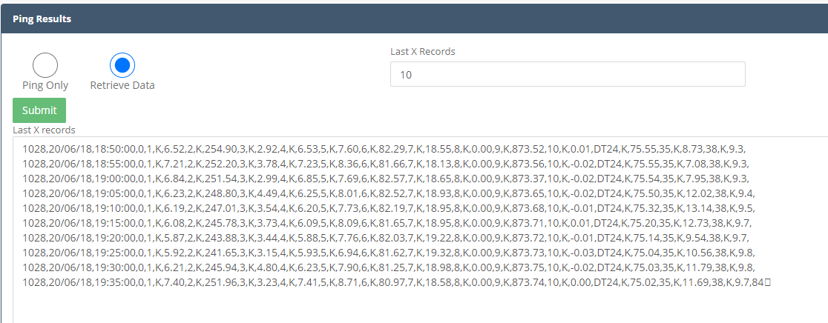

* **Manual Poll and Store (only available for Weather.com weather stations):** Will retrieve data from weather station and store the hourly data. Use this option if you want to pull data immediately and don’t want to wait for the QREST scheduled task to retrieve data

# Air Data Management

## Air Data Retrieval and Processing Workflow

Air data is retrieved and processed in QREST using the following process:



**Section 2.6.1**

**Section 2.6.2**

**Section 2.6.3**

**Previous Sections**

Boxes in yellow are described in previous sections; sections in green are described in the following sections.

### QREST Polling Task

The Polling Task is designed to run at a predefined frequency, each perform the following tasks each time it runs:

1. Retrieve the list of sites that are configured for polling in QREST, and for each site perform the subsequent steps.
2. Retrieve data:
   1. Establish a connection with the remote data logger for the site
   2. Retrieve the last X records logged at the site
   3. Terminate communication with the data logger
3. Parse, validate, and write data:
   1. Parse the text file coming from the data logger according to the QREST Polling Configuration defined for the site (i.e. identifying which columns map to which parameters)
   2. If n-minute alerts have been defined for the monitor (for example if the n-minute record value is higher than the alert level set for that monitor), send out these n-minute alerts.
   3. Insert the n-minute record to the database

### Hourly Data Calculation (automatic)

Any time a data record is inserted (or updated) in an n-minute data table, a trigger is immediately run on that record that performs the following:

* Lookup the summary type, local timezone, and expected decimal places that has been defined in QREST for this parameter at this site (defined in the polling configuration). The summary type could be Average, Maximum, Minimum, Total, Angular Average, or Angular Standard Deviation)
* Calculate (or recalculate) the hourly summary for the hour in which that n-minute record belongs, rounding to the specified precision
* Add up the number of records that exist in QREST for the hour in which that n-minute record belongs
* If less than 75% of records for the hour are in QREST, then replace the calculated summary with the code “FEW”
  + Store the calculated hourly record, storing both the raw UTC time and the local time

### QREST Alert Notification Task

Every hour a task runs that validates any new or updated data that hasn’t yet been validated yet. This task performs the following steps:

1. Select all hourly records for which alert notification task has not yet run
2. For each record in #1 above:
   1. **Lost Data:** Insert missing hourly records for any hours that are missing. For these records, write “LOST” for data flag
   2. **Min Violation:** Write “MIN” validation code for any records below the minimum alert level for the monitor.
   3. **Max Violation:** Write “MAX” validation code for any records above the maximum alert level for the monitor.
   4. **Data Jumps:** Write “JUMP” validation code for any records that have an amount change from the previous hourly record that exceeds any alerts set for the monitor.
   5. **Stuck Values:** Write “STUCK” validation code for any records that have repeating hourly values exceeding any alerts set for the monitor.
   6. **Removal of LOST flag:** for any values that have had a numeric value retrieved but previously were flagged as “LOST”, the “LOST” flag is removed
3. Finally, the VAL_IND for these records is set to 1, indicating that the record has been validated and does not need to be validated again.

## Raw Data

The Raw Data screen allows the user to view n-minute or hourly data in QREST.

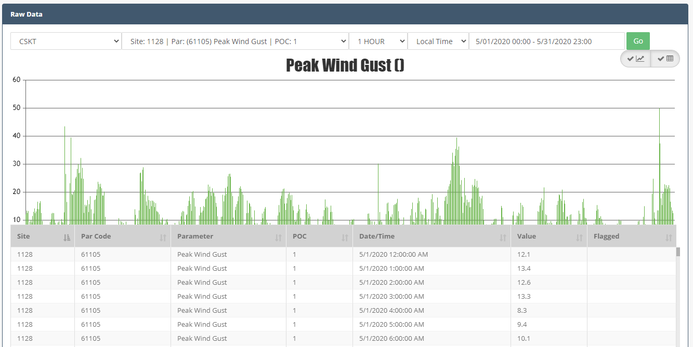

Data on this screen is read-only. To edit the data, apply flags, or prepare the data for AQS submission, go to the Data Review page.

## Quality Assurance: Data Review

### Data Review Workflow

Data Operators or QA Reviewers will periodically review air monitoring data. QREST will organize data review into monthly activities. For each month, the following main tasks need to be performed for hourly data:



1. **Retrieve, Calculation and “Level 0” Review (automatic):** Data retrieved and calculated from n-minute data to hourly data. “Level 0” automatic flags applied to the data by QREST (i.e min/max/stuck values/data jump alerts)
2. **AQS Readiness:** Data made AQS ready, meaning that either a numeric value has been received, or a Null Qualifier has been applied to the hourly record.
3. **Level 1 Validation:** Data Operator confirms each record has passed Level 1 Validation
4. **Level 2 Validation:** QA Reviewer confirms each record has passed Level 2 Validation
5. **Supporting Documentation Uploaded:** Operator or QA Reviewer uploads supporting documentation
6. **AQS Submission:** Data is submitted to EPA-AQS

The user can see a general overview of the monthly data retrieval and review progress at the Data Review screen by selecting a site and month to review:

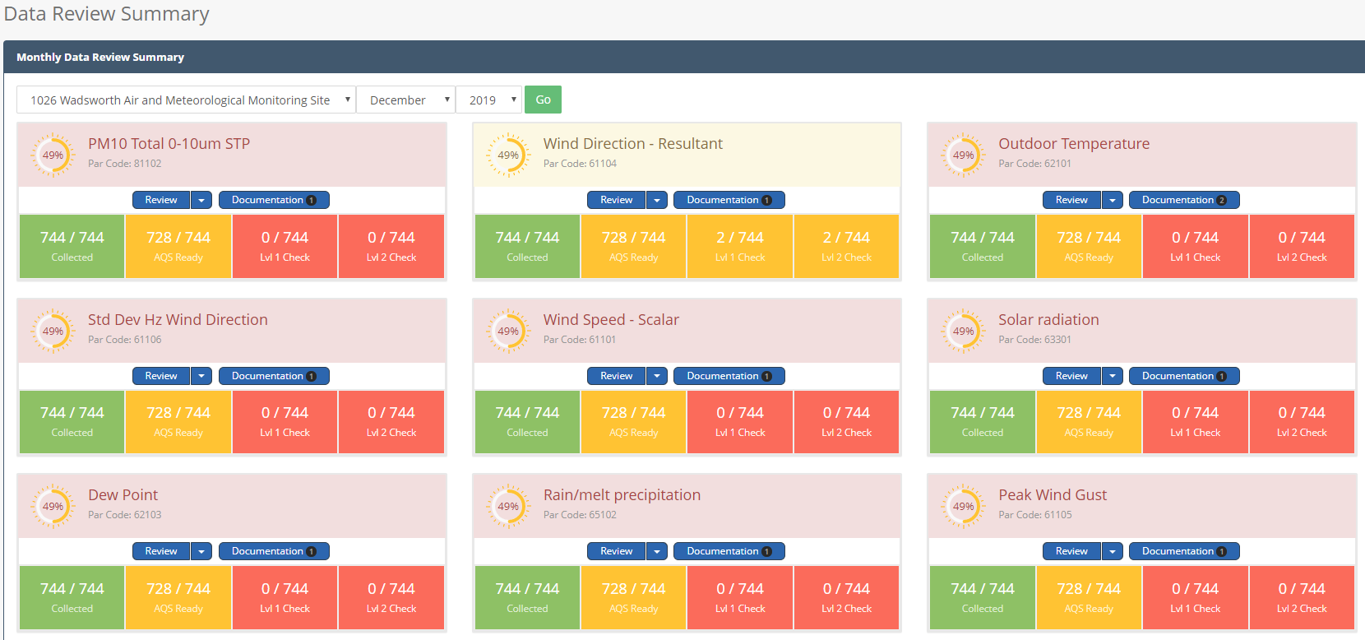

This screen lists all parameters monitored at the site and indicates the overall completion percentage for the month for each parameter. The parameter is color coded to display the progress for (1) data retrieval (2) AQS readiness (3) Level 1 validation, and (4) Level 2 validation

The user can click on the **Review** button to review the hourly data for that parameter, which will display the following:

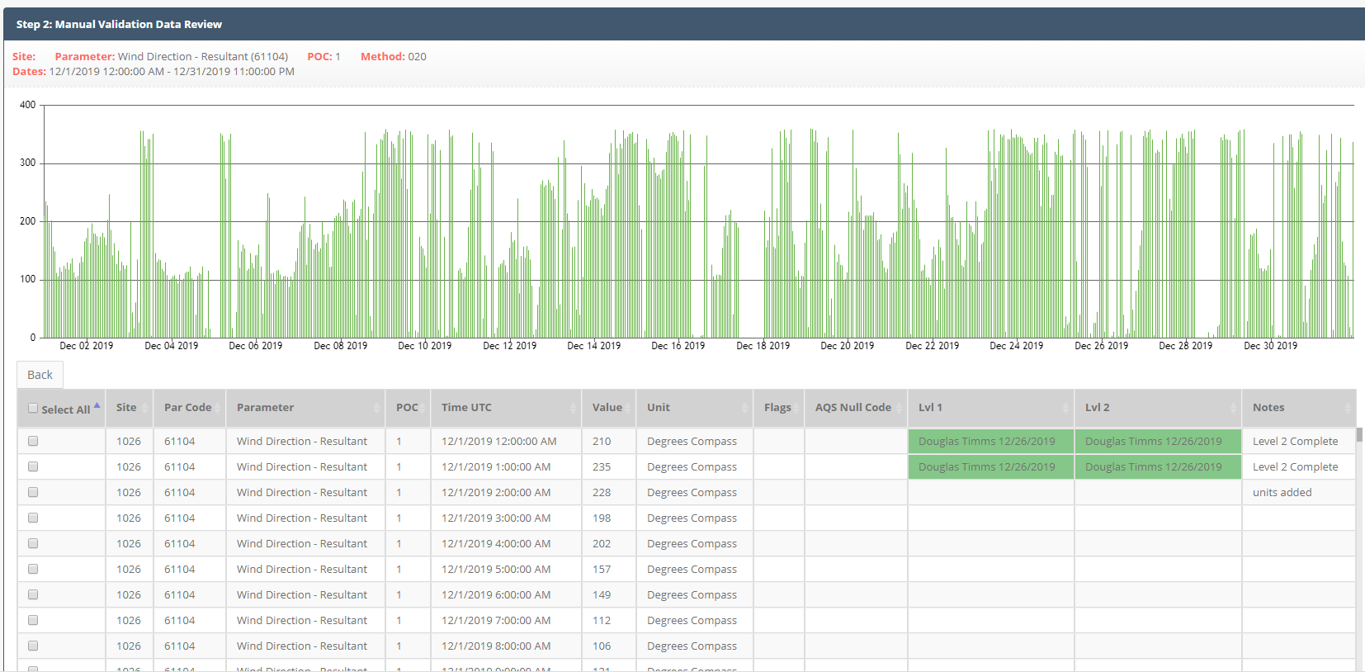

The user can view the data graphically. Data in the graph will be color coded as follows:

* **Yellow:** indicates that too few n-minute data values were received for the particular hour, and data has been flagged as “FEW”
* **Red:** indicates the record exceeded either the minimum alert or maximum alert for the hour and data has been flagged as “MIN” or “MAX”
* **Purple:** indicates the data value amount change since the previous hour exceeded the JUMP alert and data has been flagged as “JUMP”
* **Green:** all other data

The user can click and drag their mouse to zoom in on a particular portion of the month, and can also use the chart’s panning feature to pan the window left or right. As the user pans or zooms the chart, the corresponding table of data below will update accordingly.

When the user is ready to edit, add notation, or validate the data, they click the checkbox in column 1 of the data table, which will cause the “Bulk Edit Selected” button to appear as shown here:

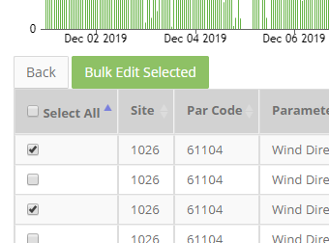

Clicking that button will display the edit panel, as shown here:

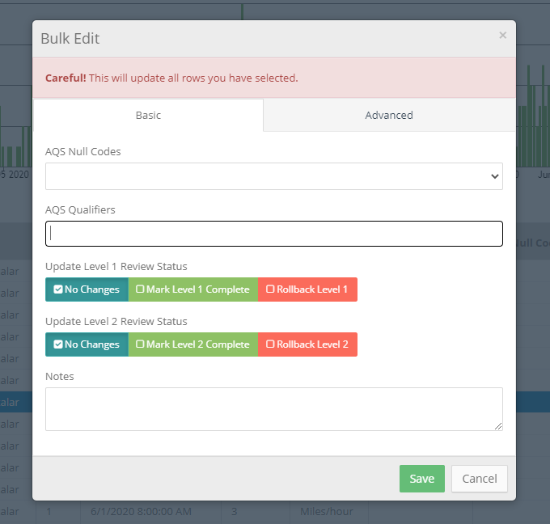

This consists of 2 tabs and allows the user to do the following:

* **Basic Tab:**
  + Apply an AQS Null Qualifier Code to the selected data
  + Apply one or more AQS Qualifier Codes to the selected data
  + Perform Level 1 Validation (or rollback validation).
  + Perform Level 2 Validation (or rollback validation). This is only available to QA Reviewers or Admins
  + Add notes (required)
* **Advanced tab:**
  + Bulk modify the value for the selected data
  + Bulk modify the unit code for the data. This is only be accessible by QA Reviewers or Admins
  + Apply a QREST Flag. QREST flag is used to record that the data exceeded a min/max alert
  + Bulk Delete the records (only available to Admins)

### Data Review Documentation

QREST will allow users to upload documentation associated with a monthly data review. The user will click on the **Documentation** button on the Data Review page to add documents.

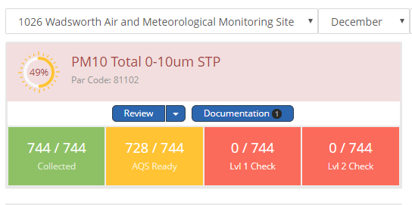

**Indicates that 1 document already uploaded for PM10 for December**

The user will be able to upload documents that apply to the parameter only (right column) or documents that apply site-wide (left column).

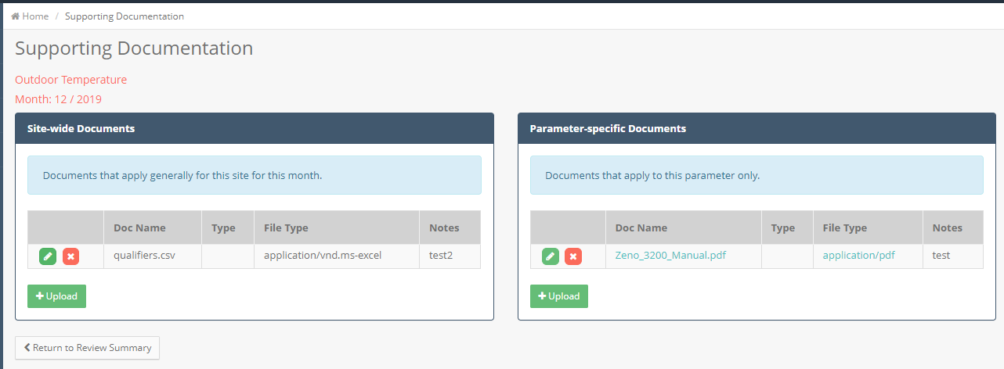

The user can click the **Upload** button to add new documents.

### Advanced Review Options

The typical review assumes review of hourly data for a 1-month duration, looking at a single parameter. Users can opt for advanced review options, as shown here:

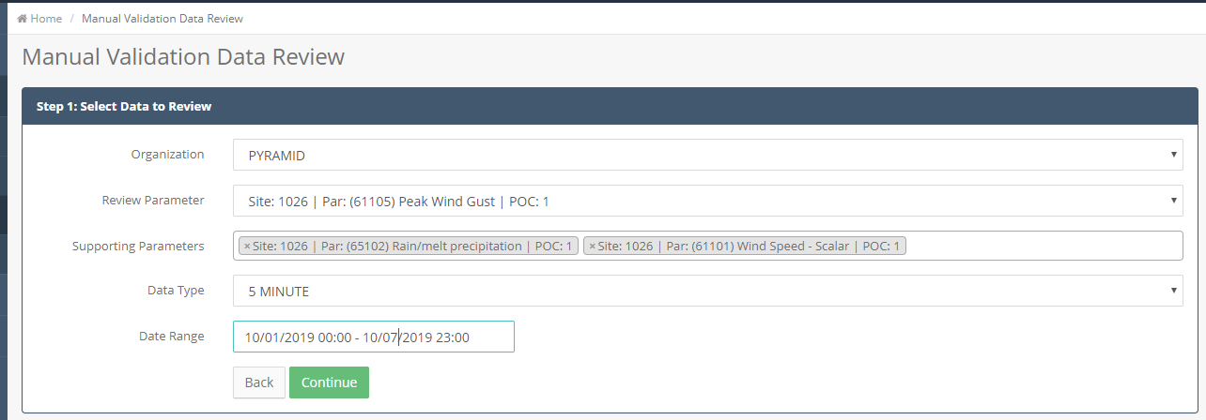

This allows the user to review (1) additional parameters, (2) n-minute data, and (3) a date range other than 1 month’s worth of data, as shown here:

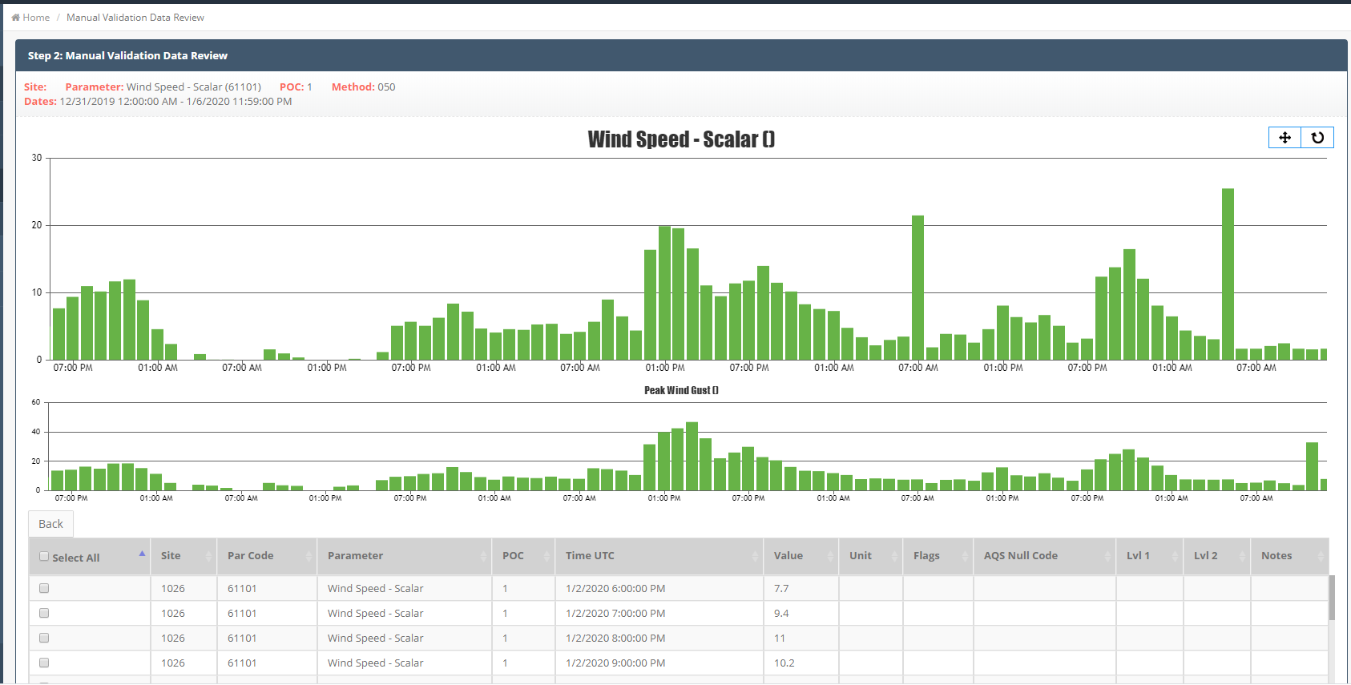

## Manual Raw Data Import

### Introduction

Users can upload hourly or five minute raw data to QREST. This can be used in situations where automatic polling is not configured, to fill in historical or lost data, or to make bulk corrections to data.

QREST allows the import of 3 different file types:

* **Hourly Data of 1 parameter, where the hourly results are arranged as 24 columns**, such as this example

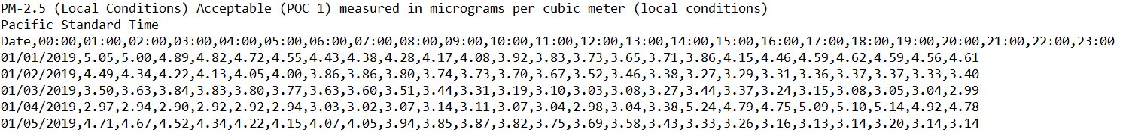

When importing using this type, the user needs to specify the site and parameter that is being imported, as well as what time zone and whether the data is tracked in local standard time or UTC time.

* **Hourly Data, with different parameters appearing in different columns**, such as this example:



In order for QREST to understand what appears in each column, an import template must first be defined, which is described further in the following section.

* **5 Minute Data, with 1 result per row**, such as this example

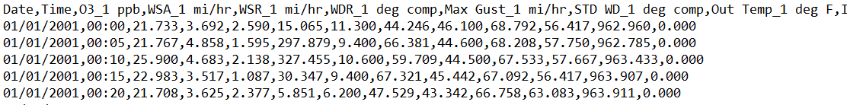

In order for QREST to understand what appears in each column, an import template must first be defined, which is described further in the following section.

### Setting Up an Import Template

If you are importing data where parameters are arranged in columns, you will need to define an import configuration, which tells QREST what parameters it should expect in each column.

To set up an import template, go to the Air Data 🡪 Manual Import screen and select the Hourly or 5-Minute import type, and then specify the organization and site to import. The following buttons will appear:

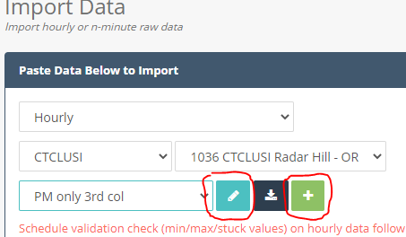

This allows the user to Add or Edit an import template.

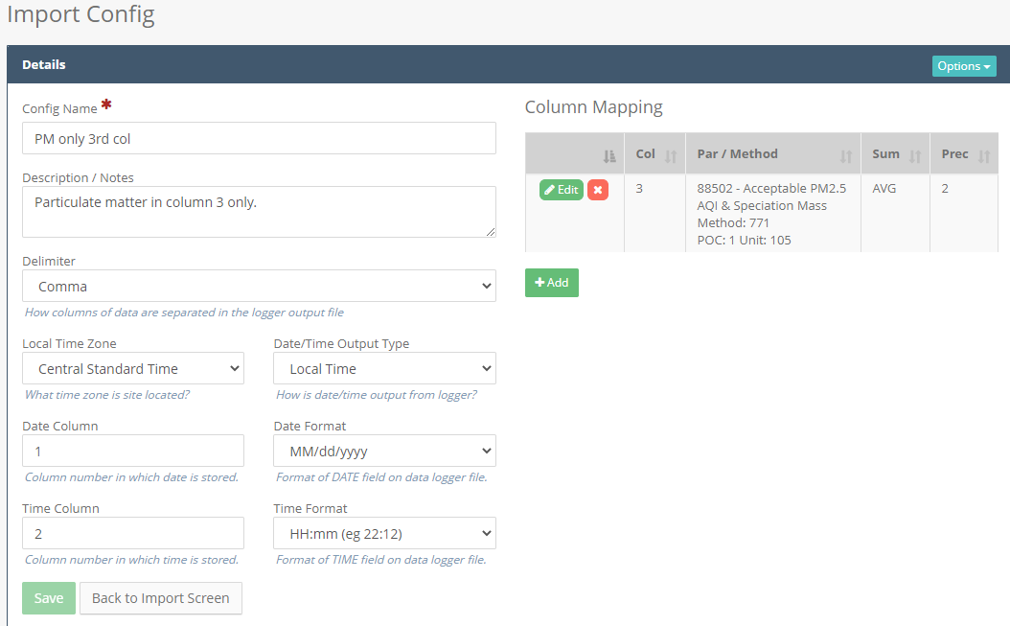

Fields to set a logger configuration include:

* **Config Name:** give your polling configuration a meaningful name. Although in the vast majority of situations, people only define 1 polling configuration per site, there are scenarios where a site may have different seasonal polling configurations and the **Config Name** will help you keep track of these different configurations.
* **Delimiter:** How columns of data are separated in the logger output file
* **Local Time Zone:** the time zone in which the site is located
* **Date/Time Output Type:** identifies how data is being output on the data logger, either in local standard time or UTC time
* **Date Column:** Column number in which date is stored.
* **Date Format:** Format of DATE field on data logger file.
* **Time Column:** Column number in which time is stored.
* **Time Format:** Format of TIME field on data logger file.

**Column Mapping**

* **Column Mapping:** the column mapping section allows the user to define the parameters that are monitored at the site. For each parameter being logged by the logger, define:
  + **Parameter/Method:** parameter/method stored in the specified column
  + **Column #:** Column number in which the parameter appears in the data logger file. For example, if your import file looks like the following:

1128,20/06/19,02:45:00,0,1,K,4.20,**2,K,221.50**,3,K,21.40,4,K,4.40,5,K,8.70,35,K,16.2488

1128,20/06/19,02:50:00,0,1,K,5.60,**2,K,225.80**,3,K,15.70,4,K,5.80,5,K,9.00,35,K,17.9745

1128,20/06/19,02:55:00,0,1,K,5.50,**2,K,218.70**,3,K,17.30,4,K,5.70,5,K,9.50,35,K,16.0348

1128,20/06/19,03:00:00,0,1,K,5.50,**2,K,221.00**,3,K,16.50,4,K,5.70,5,K,8.90,35,K,11.7177

1128,20/06/19,03:05:00,0,1,K,5.40,**2,K,226.00**,3,K,17.60,4,K,5.50,5,K,8.90,35,K,9.4351

**1 2 3 4 5 6 7 8 9 10**

And Wind Direction is bolded above, the column # value would be **10** because the Wind Direction values above (221.50, 225.80, 218.70, 221.00, 226.00) appear in the 10th column in the file above.

### Importing Data

When ready to import data, the user will select the import type, organization, site, and (if applicable) import template, and then copy/paste their data into the textbox, as shown here:

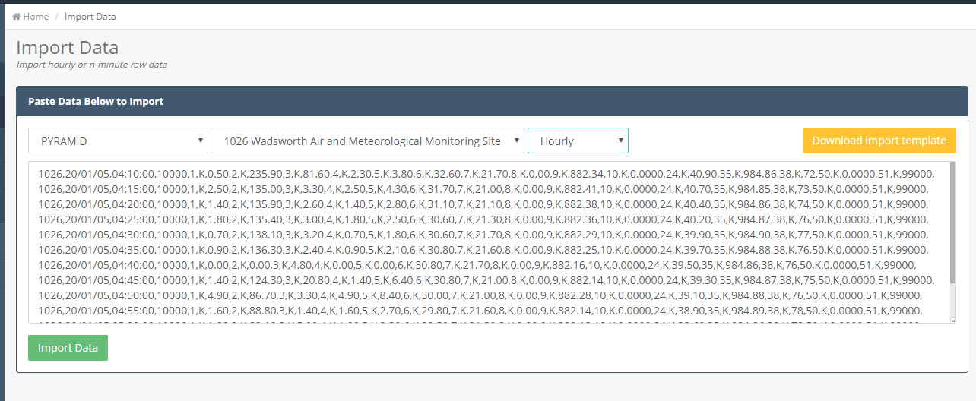

QREST supports pasting data from comma-separated text files or Excel spreadsheets. (When importing from Excel, the default will be tab delimited data.) After pasting, click the **Import Data** button.

QREST will then perform the following steps:

1. **CREATE IMPORT RECORD:** First creates a unique import ID for this import attempt, and stores a copy of the block of data you are attempting to import. Sets the import status to **STARTED**.
2. **ESTIMATE IMPORT DURATION:** Determines if the import data is small enough to import immediately, or if too large, schedules it to run in a QREST background queue. If import file is not very large, proceed immediately on to next step.
3. **PARSE/VALIDATE/STAGE:** Parses and validates import data and writes to staging table.
   1. Update import status to **VALIDATING**
   2. This includes the following validations:
      1. Skips any blank rows or rows that don’t have delimited data
      2. Marks record as failed if date or time cannot be read
      3. Calculates and stores both UTC and local time for record
      4. If value is numeric, store as numeric
      5. Else if value is not numeric do the following non-numeric handling:
         1. Strip out any asterisk (*) characters from non-numeric codes. This is to allow people to import AQS QA codes such as “6” for “QAPP Issue”. People can import this data as “*6” so QREST knows it should be imported as an AQS Code and not as a numeric value of 6.
         2. If non-numeric length > 5, fails validation (allowable codes cannot exceed 5 characters in length)
         3. Else if non-numeric and matches an AQS NULL Code, then store result as the AQS Null Code
         4. Else if non-numeric and matches AQS QUAL Code, then store result as the AQS Qualifier Code
         5. Else store the non-numeric as a user-defined code
      6. Marks any records as “duplicate” if a record already exists in QREST for that monitor and datetime.
   3. Update import status to **VALIDATED**
4. **PAUSE FOR USER CONFIRMATION:**

* **No validation errors:** If no validation errors are found, QREST will immediately move on to the following step.
* **Existing Data Found:** If existing data is already in QREST for the monitor and date/time, the import will pause and require the user to confirm whether they wish to proceed with the import. If they choose yes, QREST will proceed with the following step and the old data will be overwritten with the new data. An example is shown here:

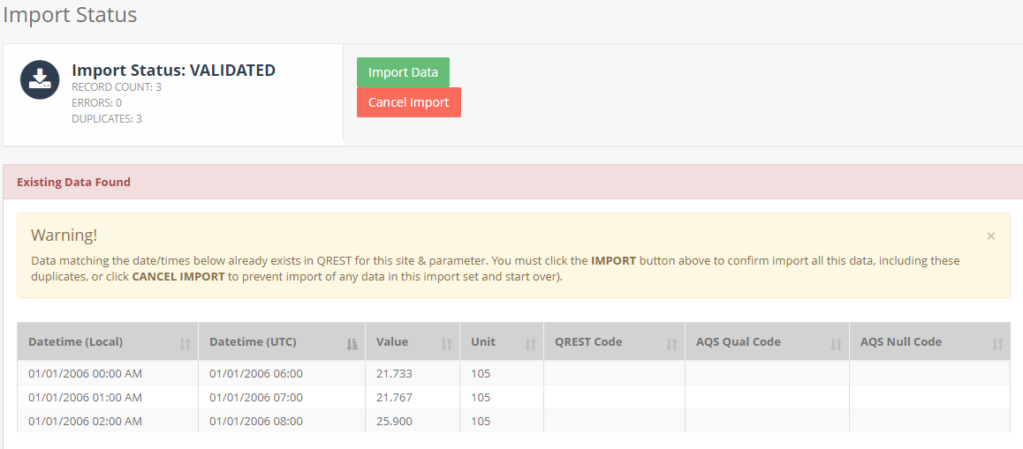

* **Validation Errors**: If validation errors are found, the import will stop. The user will need to fix the source data file and re-attempt the import.

1. **FINAL IMPORT:**
   1. Update import status to **IMPORTING**
   2. Bulk copy data from import staging table to either HOURLY or FIVE_MINUTE table, which may include data inserts or data updates on overwriting existing data.
   3. Update import status to **IMPORTED**
2. **PERFORM LEVEL 0 DATA VALIDATION (optional):** If user is importing hourly data and has indicated on the import screen that they wish to schedule validation check (min/max/stuck values), then QREST will validate all imported data against the min/max/jump/stuck value alerts defined for that monitor.

### Import History

You can go to Air Data 🡪 Manual Import and click on the **View Import History** button to view a history of all data imports you have conducted.

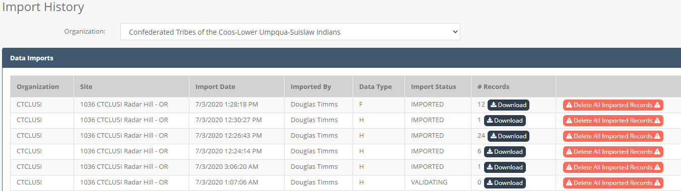

For each import you can view the import type, import date, import status, and number of records in the import.

**IMPORTANT NOTE:** the number of records indicates the number of records **currently in QREST** that correspond with the import file. If data is imported, and then imported a second time, thus overwriting data in the first import, then the number of records tied to that original import will be zero.

You can download an Excel file with all data corresponding with an import. In addition, you can delete all data corresponding to a particular import. This is useful if you perform a data import and realize a mistake was made and wish to back out the imported data from QREST. Be careful: this cannot be undone.

## Quality Control

QREST allows users to enter information regarding a variety of quality control checks. QREST performs validation on these checks to determine if the data is valid according to EPA criteria. Finally, the user can use QREST to submit this QC data to AQS.

### QC Types

QREST allows the entry of the following QC Types:

* **One-Point QC:** The bi-weekly one-point QC check is required to be reported within the range of 0.005- 0.08 ppm for O3, SO2 and NO2 and 0.5- 5 ppm for CO. The QC check gas concentration selected within the prescribed range should be related to the monitoring objectives for the monitor. If monitoring at an NCore site or for trace level monitoring, the QC check concentration should be selected to represent the mean or median concentrations at the site. If the mean or median concentrations at trace gas sites are below the MDL of the instrument the agency can select the lowest concentration in the prescribed range that can be practically achieved. If the mean or median concentrations at trace gas sites are above the prescribed range the agency can select the highest concentration in the prescribed range. An additional QC check point is encouraged for those organizations that may have occasional high values or would like to confirm the monitors' linearity at the higher end of the operational range or around NAAQS concentrations. If monitoring for NAAQS decisions, the QC concentration can be selected at a higher concentration within the prescribed range but should also consider precision points around mean or median monitor concentrations. Due to the audit levels being expanded to allow for lower concentration audits to support NCore and trace-level work, a May 5, 2016, Technical Memo5 was posted on AMTIC in which EPA suggests the use of “dual” acceptance criteria for one-point QC checks that are performed at lower concentration ranges. The data is evaluated in the AQS AMP256 Report under “One Point Quality Control”.
  + O3: + 1.5 ppb difference or + 7 percent difference, whichever is greater (from 5-21.5 ppb, 1.5 is greater than 7%)
  + SO2: + 1.5 ppb difference or + 10 percent difference (from 5-15 ppb, 1.5 is greater than 10%)
  + NO2: + 1.5 ppb difference or + 15 percent difference (from 5-10 ppb, 1.5 is greater than 15%)
  + CO- NOTE: since the low end of CO one-point QC checks is 0.500 ppm, the absolute difference acceptance criteria that was developed for the annual PE (+ 0.03 ppm for concentrations <0.200ppm) will not be in effect.
* **Annual Performance Evaluations (PE):** the Annual PE includes 10 audit levels for the gaseous pollutants of SO2, NO2, O3, or CO. The evaluation is made by challenging the monitor with audit gas standards of known concentration from at least three audit levels. One point must be within two to three times the method detection limit of the instruments within the PQAOs network, the second point will be less than or equal to the 99th percentile of the data at the site or the network of sites in the PQAO or the next highest audit concentration level. The third point can be around the primary NAAQS or the highest 3- year concentration at the site or the network of sites in the PQAO. An additional 4th level is encouraged for those agencies that would like to confirm the monitors' linearity at the higher end of the operational range. Due to the audit levels being expanded to allow for lower concentration audits to support NCore  and trace-level work, a February 11, 2011, Technical Memo6 was posted on AMTIC in which EPA suggests the use of the following acceptance criteria for levels 1 and 2 audit ranges:
  + For O3, SO2, and NO2:+ 1.5 ppb difference or + 15 percent difference, whichever is greater.
  + For CO: + 0.03 ppm difference or + 15 percent difference, whichever is greater.

For audit levels 3-10, the 15 percent difference acceptance criteria, currently in guidance, is acceptable. The data is evaluated in the AQS AMP256 Report under “Annual Performance Evaluation”.

* **Zero Span:**Zero and Span are two different measurements that are quality control checks. The zero check is a challenge of the instruments zero calibration conducted by introducing zero air into the analyzer and measuring the instrument response. The span check is a challenge of the upper limit of the analyzers calibration conducted by introducing a calibration gas (approximately 80% of the operating range) into the analyzer.
* **Flow Rate Verification:**A one-point flow rate verification check on automated and manual monitors used to measure PM10, PM10-2.5, PM2.5, and Pb (Pb-TSP and Pb-PM10). To perform the flow rate verification check, the monitor’s normal flow rate is checked using a certified flow rate transfer standard. This check is performed at different frequencies depending on the type of monitor being used. For manual method hi-vol samplers, flow rates must be verified on at least a **quarterly basis**. For manual method lo-vol samplers, flow rates must be verified on at least a **monthly basis**. For automated methods, flow rates must also be verified **monthly**.  
  Particulate monitors using automated methods usually sample continuously and report hourly average values as raw data to AQS. When this check is performed, if the hourly average raw data value is not available for reporting, then a null value and null data code is reported for that hour. The known flow rate of the transfer standard, and the measured (or indicated) value from the monitor, are recorded by the operator for entry into AQS for that monitor on that date. For manual monitors, the check is performed prior to or after sampling so there is no data loss.
* **Semi Annual Flow Rate Audit:** The Semi-Annual Flow Rate Audits should be performed at least every 6 months on each monitor used to measure PM10, PM10-2.5, PM2.5 and Pb. To perform the audit, the monitor’s normal flow rate is checked using a certified flow rate transfer standard which is different from the one used for calibrating the monitor. The auditing agency conducting the Semi-Annual Flow Rate Audit may be the PQAO, or may be an independent agency. In any event, the assessment should be conducted by other than the routine site operator.  
  Particulate monitors using automated methods usually sample continuously and report hourly average values as raw data to AQS. When this audit is performed, the hourly average raw data value may not be available for reporting, in which case a null value and null data code are reported for that hour. The flow standard value (known flow rate of the transfer standard), and the monitor value (response value indicated by monitor) are recorded by the operator for entry into AQS for the monitor being assessed, for that date. For manual monitors the assessment can be performed prior to or after sampling so there is no data loss.

### QC Data Entry

To create a Quality Control records, navigate to the Air Data 🡪 Quality Control left menu. This will display a listing of any quality control checks that have already been entered.

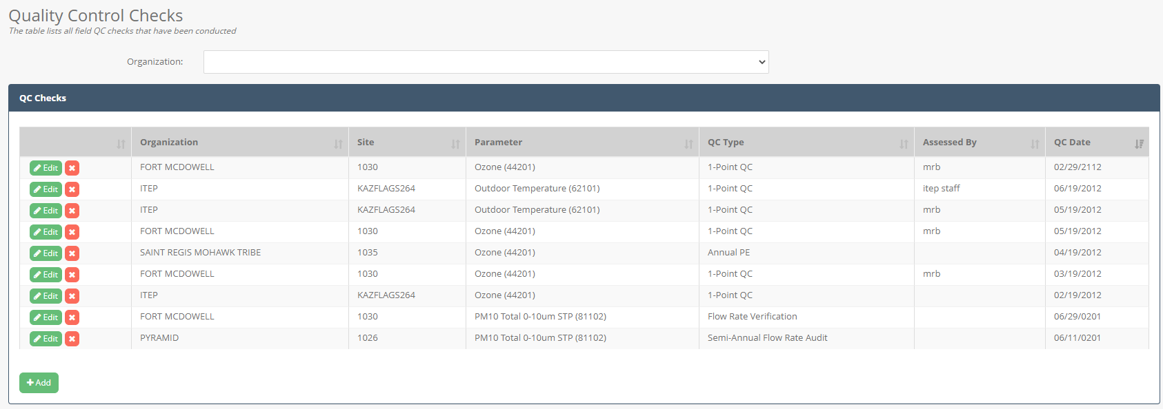

Click on the **Add** button to add a new QC Check or the **Edit** button to edit an existing QC check.

When creating a new QC entry, select the assessment type, monitor, assessment date, and optionally the time and who made the assessment. After clicking save, QREST will create one or more blank rows to enter the assessment details:

* 10 rows for Annual Performance Evaluation
* 1 row for all other assessment types

Here’s an example of the 10 blank rows created for an Annual Performance Evaluation:

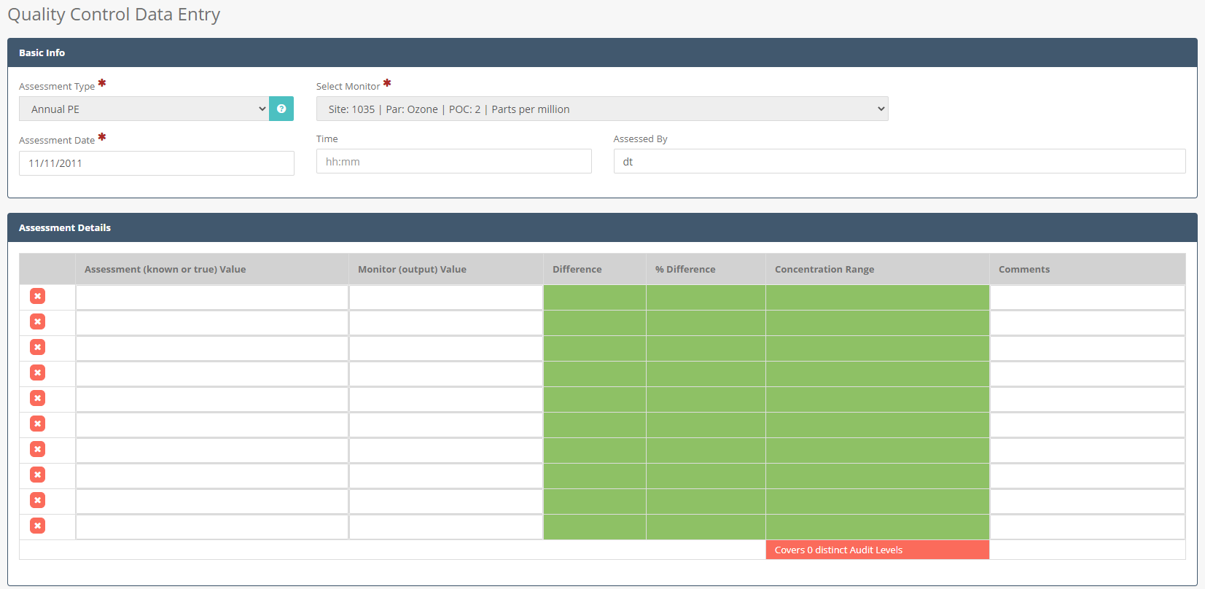

For each row, enter in the Assessment (known) value and the monitor output value. After clicking save, QREST will evaluate the values and shade them green if they pass validation checks or red if they fail validation checks.

**Validation Checks:**

* **Annual Performance Evaluation:** 
  + **Distinct Concentration Range Check:** Assessments must cover 3 of the 10 concentration ranges defined by EPA
  + **Percentage Difference Check:** 
    - Sulfur Dioxide (42401, 42406): must be less than 15% difference
  + **Concentration Difference Check:** 
    - Sulfur Dioxide (42401, 42406): must be less than 1.5 ppb
* **1-Point QC:** 
  + **Concentration Range Check:** 
    - Sulfur Dioxide (42401, 42406): concentration must be between 5 – 80 ppb
    - Ozone (44201): concentration must be between 5 – 80 ppb
  + **Percentage Difference Check:** 
    - Sulfur Dioxide (42401, 42406): must be less than 10% difference
    - Ozone (44201): must be less than 7% difference
  + **Concentration Difference Check:** 
    - Sulfur Dioxide (42401, 42406): must be less than 1.5 ppb
    - Ozone (44201): must be less than 1.5 ppb
* **Flow Rate Verification & Semi Annual Flow Rate Audit:** 
  + **Percentage Difference Check:** 
    - PM 2.5 (81104, 88101, 88500, 88501, 88502): must be less than 4.1% difference
    - PM 10 (81102, 85101): must be less than 7.1% difference

### AQS QC Data Submission

When the QC data has been completely entered, the user can click on the **Send to AQS** button to initiate the AQS submission process. This will allow you to select some AQS file generation options such as data format and action code:

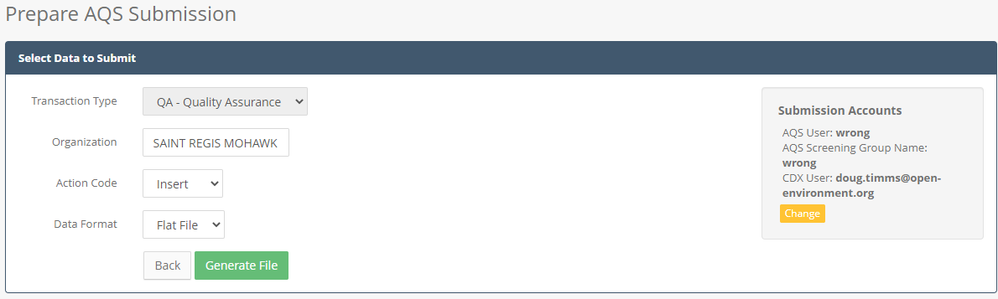

Click the **Generate File** button to generate the AQS file. You will then be shown the AQS submission tracker page.

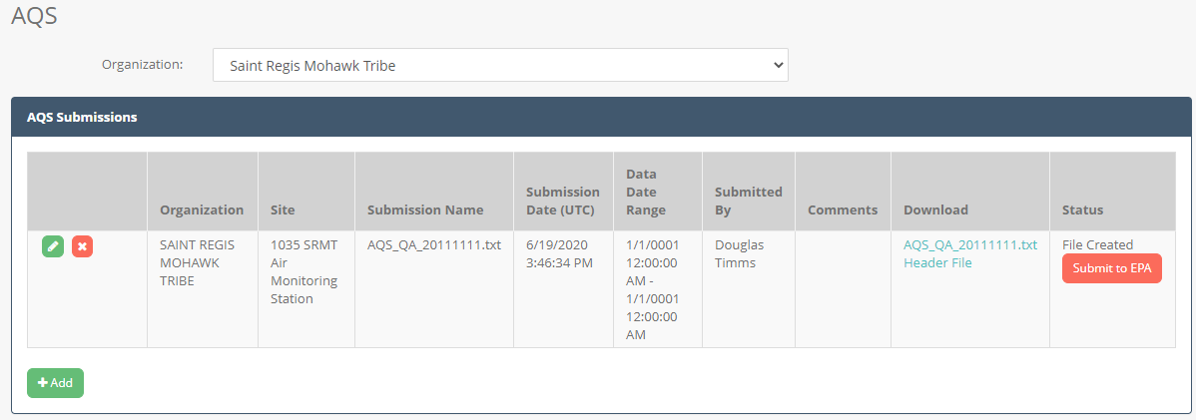

Click on the links in the **Download** column if you wish to view the file that has been generated. QREST stores 2 files related to the AQS submission:

* Text file containing only the AQS data
* “Header” file which is a zip package containing the AQS data file wrapped in an Exchange Network header XML file. This is the package that is sent to EPA’s Exchange Network Node.

Or click the **Submit to EPA** button to send the file to EPA.

## AQS Raw Data Submission

QREST is capable of generating AQS submission files and submitting them directly from QREST to AQS via the Exchange Network. To make an AQS submission of QC data, please refer to the QC section of this guide.

### Initial QREST Configuration Required Before Making AQS Submissions Through QREST

In order to make an AQS submission, first several items must be properly configured. These configuration steps only need to be done once. These steps are:

1. **AQS User Account:** The user must have an EPA AQS account with Screening Group access. The user must contact EPA’s AQS program to obtain an AQS account.
2. **Exchange Network Account (optional):** The user can also optionally create an Exchange Network account that will be used to make the submissions to AQS. Contact the EPA Helpdesk ([nodehelpdesk@epacdx.net](mailto:nodehelpdesk@epacdx.net)) to create this account. This is optional because QREST allows AQS files to be submitted either using a tribe’s own Exchange Network account, or its built in Exchange Network account.
3. **Authorize the Exchange Network Account from #2 above to submit on for the AQS account in #1 above:** Log into AQS using the AQS account from #1 above, and navigate to the Admin 🡪 Security page. Here, you should fill in the Exchange Network (EN) account you selected from #2 above, as shown here:

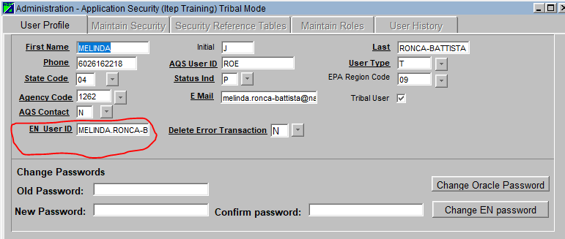

1. **Configure QREST with credentials from steps #1-#3 above.** In QREST navigate to the Air Data 🡪 AQS Submission screen 🡪 click on the Add button, then select the Site you wish to submit for in the dropdown. On the right side box it lists the credentials that QREST will use to make the AQS submission. Click the **Change** button to setup these credentials

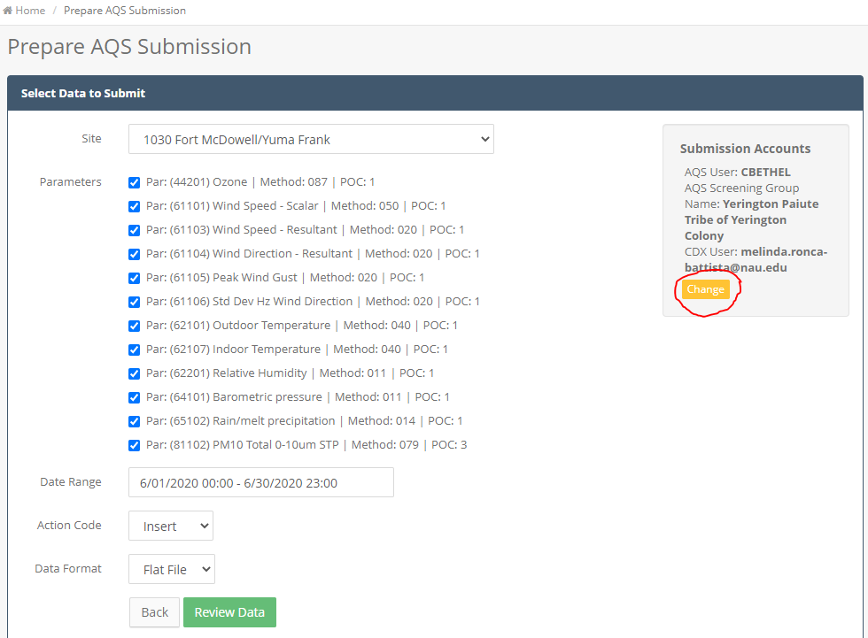

Here, enter the correct credentials:

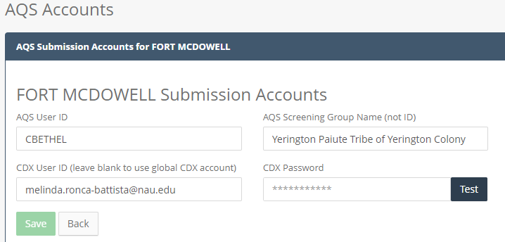

* **AQS User ID:** The AQS user ID setup from Step #1 above.
* **AQS Screening Group Name:** The screening group (agency) name in AQS. This should match exactly the screening group name shown here:

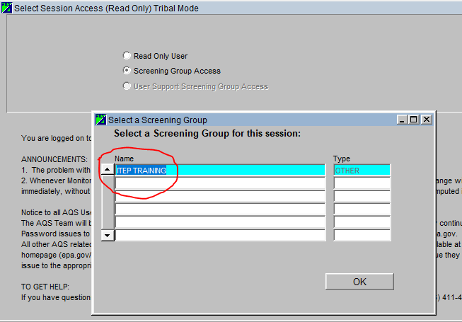

* **CDX User ID:** The EN UserID configured according to Step #3 above. You can choose to leave this blank and let QREST use it’s default CDX account to make submissions, but that account will need to be configured according to Step #3 above.
* **CDX Password:** The password for the CDX (i.e. Exchange Network) account. You can choose to leave this blank and let QREST use it’s default CDX account to make submissions, but that account will need to be configured according to Step #3 above.

### Making An AQS Submission

To make an AQS submission of Raw Data, click on the Air Data 🡪 AQS Submission left menu option. Here the user will see a history of all AQS submissions that have been made through QREST.

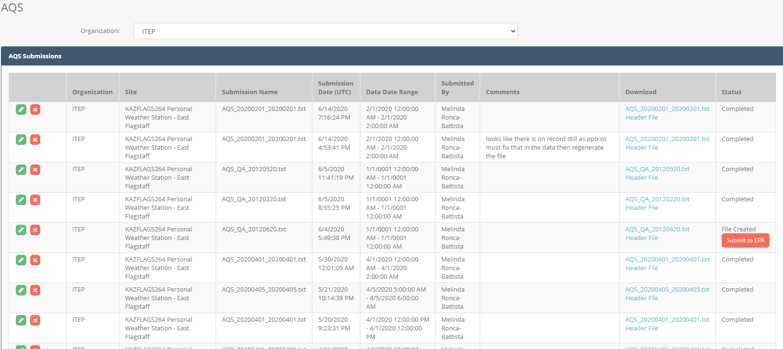

Click on the **Add** button to create a new AQS submission package.

This will load a page allowing the user to select several options for AQS generation:

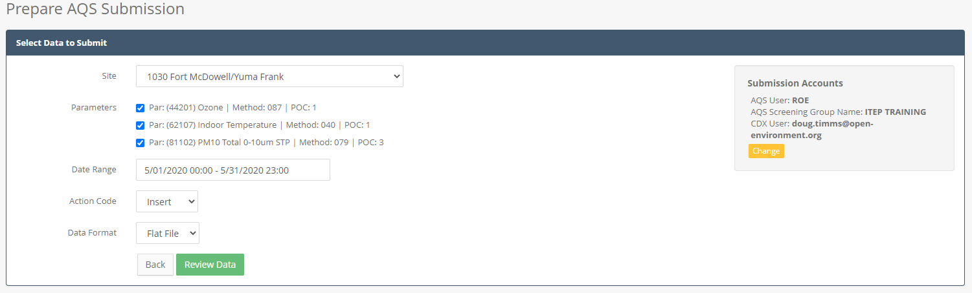

The user can then click to review the data based on the selection criteria:

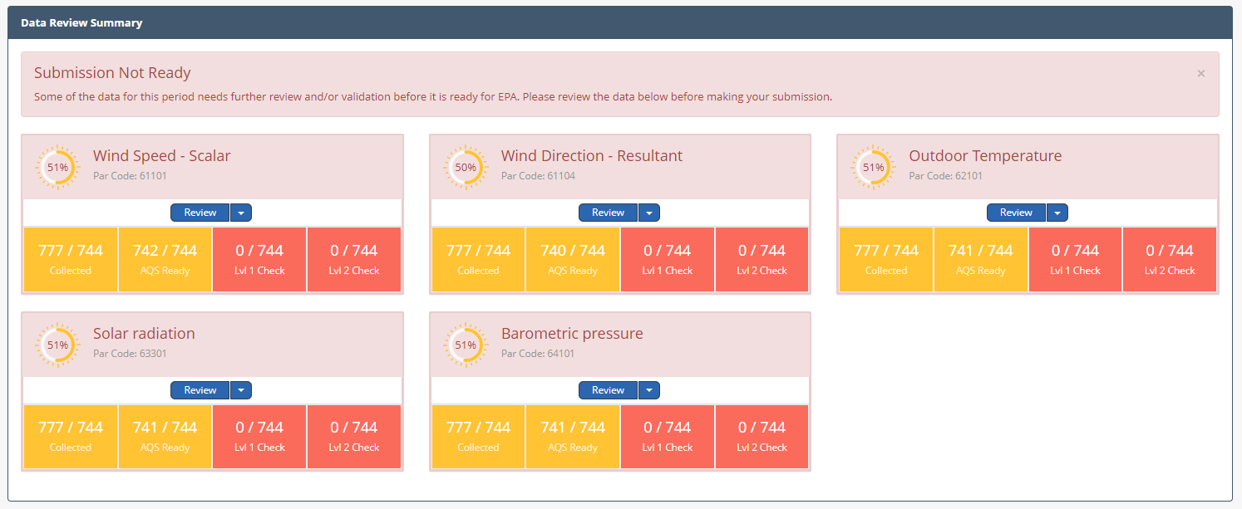

For each parameter, QREST will list:

* **Collected:** Number of hourly records collected
* **AQS Ready:** the values are either numeric, or if not numeric have an AQS Null Qualifier applied.
* **Lvl1 Check:** Level 1 validation review has been performed
* **Lvl2 Check:** Level 2 validation review has been performed

In order to make an AQS submission, all data in the date range selected must be AQS Ready and also have the Level 1 and Level 2 validation performed. If the data selected does not pass validation checks, then the following message will appear:



If all data matching the selection criteria is AQS ready and had Level 1 and Level 2 validation performed, then the **Generate File** button willappear as shown here:

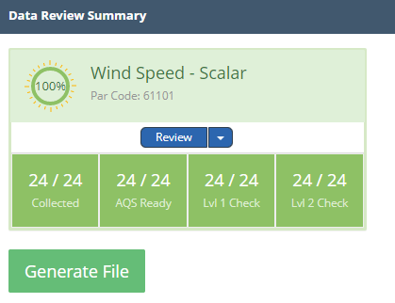

After you click the **Generate File** button, a new row will be added to the AQS submission list, as shown here.

AQS Submissions will have the following statuses:

* File Created
* Submitted-Processing or Processing or Pending
* Failed (with no validation response file yet)
* Completed (with validation response file retrieved from EPA)

**Status = File Created:**

Initially, QREST generates the file but does not send it. The use can review the file by clicking the file link, or continue to submit the file by clicking the **Submit to EPA** button.

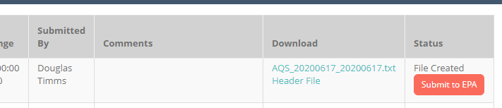

**Status = Submitted-Processing or Processing or Pending**

After the file is submitted, the status will initially be Submitted-Processing. The user can then click the **Get Status** button to find out the latest status in EPA processing. The user may need to wait several minutes for the status to update.

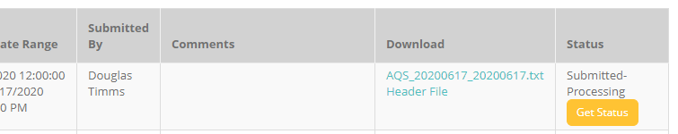

**Status = Failed**

If the status gets updated to Failed, the user can click on the **Validation Errors** link to see more details about why the submission failed.



**Status = Completed**

Evetually, if the submission passed, the status will get updated to Completed. This indicates that the submission was successful.

### Troubleshooting AQS Submission Problems

If you are making an AQS submission and the status is Failed, but the Validation Errors returned from EPA in QREST are not meaningful or blank, then one option is to log into EPA’s EN Services Center. Sometimes the EN Services Center will display more detailed error messages than QREST is able to download.

The URLS for the EN Services Center are:

* **Production:** <https://enservices.epa.gov/login.aspx>
* **Test:** <https://enservicestest.epacdxnode.net/Login.aspx>

# Public Website

## Public Map

A public map will be provided that shows all sites that are configured in QREST. The user can use this map as a jumping-off point to run various reports for the sites.

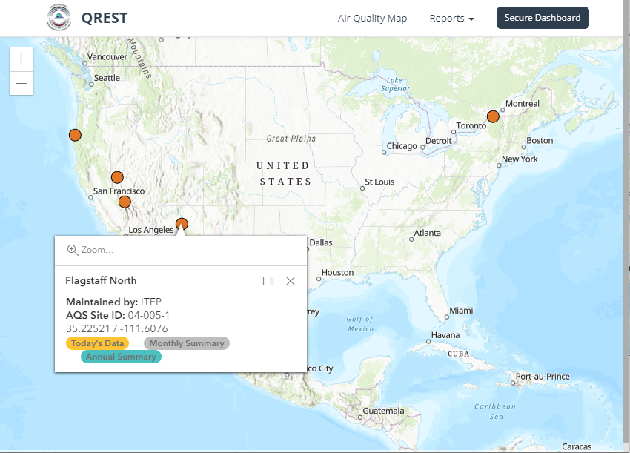

The user can hover over the site to display general site information and use links to run reports for the site.

## Reports

### Daily Hourly Data

The Daily Hourly Data Report allows users to view the hourly data for the current data at a particular site. Dropdown values will allow the user to select different sites or dates to view. The highest value for each parameter will be highlighted in red.

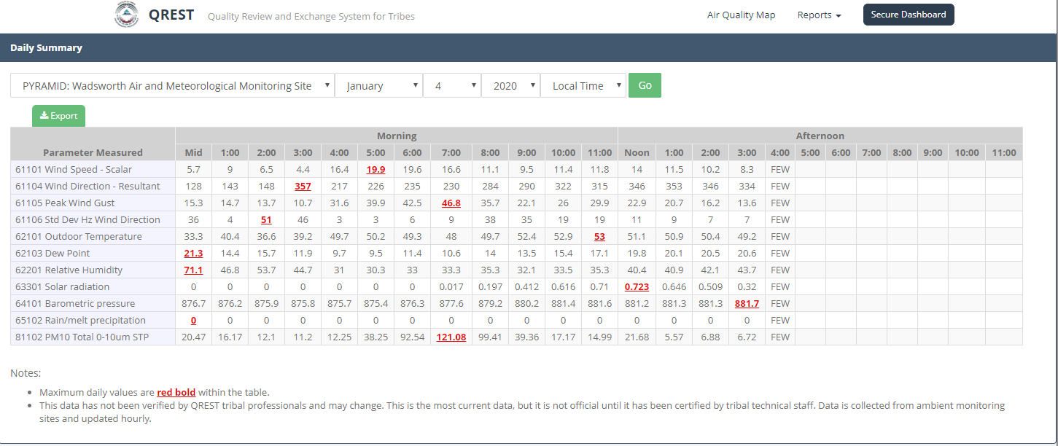

An **Export** link allows users to export data to Excel.

### Monthly Hourly Data

The Monthly Hourly Data Report allows users to view the all hourly values in a month for a particular parameter and site. Dropdown values will allow the user to select different sites, parameters, or months to view. The highest daily value for each parameter will be highlighted in red.

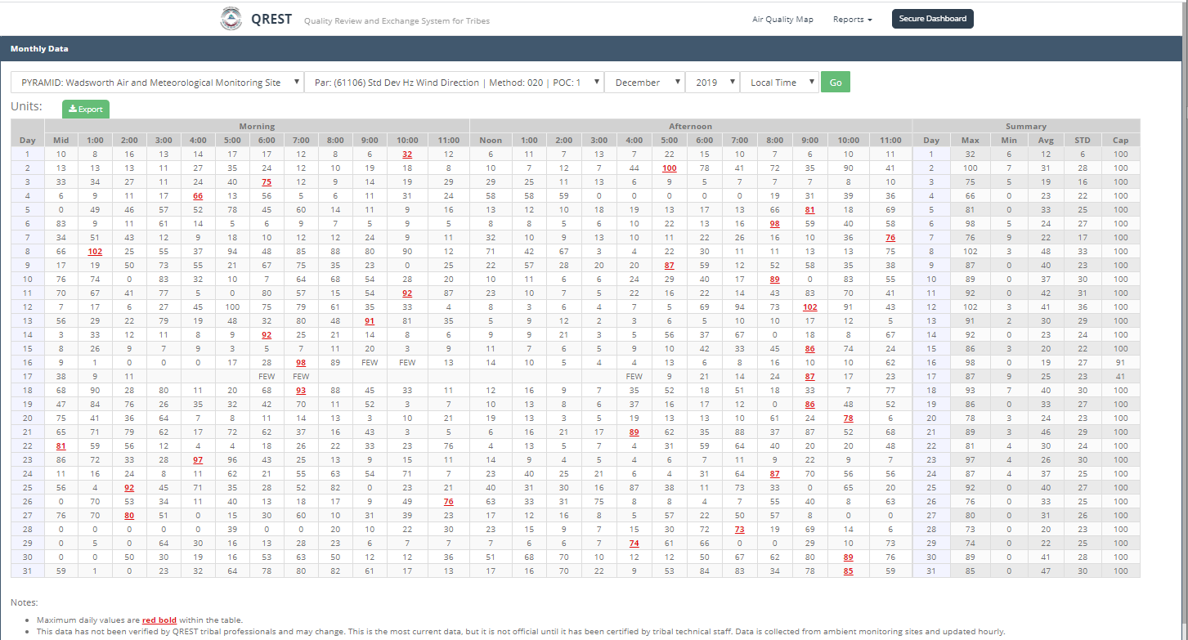

An **Export** link allows users to export data to Excel.

### Annual Hourly Data

The Annual Hourly Data Report allows users to view the all hourly values in a calendar year for a particular parameter and site. Dropdown values will allow the user to select different sites, parameters, or year to view. The highest daily value for each parameter will be highlighted in red.

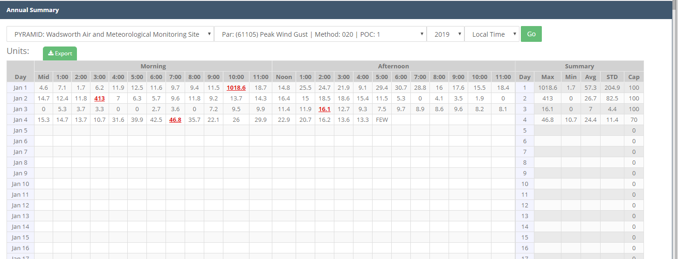

An **Export** link allows users to export data to Excel.